**Introduction to aspects related to air dryer manufacturers**

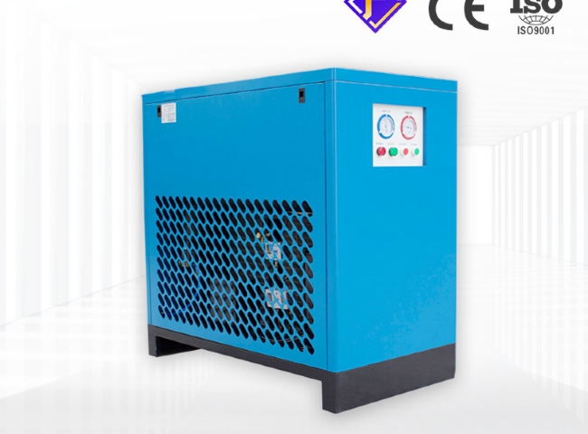

Industry performs a variety of industrial operations to achieve the end result. Most processes involve the use of compressed air for further processing.

This compressed air contains moisture and water vapor， which can cause erosion and damage and must be eliminated. Here is where the use and importance of air dryers comes into play. Air dryers help remove impurities from compressed air and keep the environment clean through their well-operated system.

Different types of air dryers can be used for different purposes such as internal heater dryers， refrigerator dryers， etc.

Now， you know the uses of air dryers. But， do you know the aspects related to air dryer manufacturers? Let us introduce this part to you.

Air dryer manufacturers.

You can get the promise of the best quality products from a keen manufacturer. You will not have to face their infidelities.

They will recognize your prerequisites and will provide products that truly match your prerequisites.

You will be able to get a huge warehouse of gadgets for various options and uses. These gadgets will be the latest in the market and can be easily used in both B2B and B2C environments.

They will familiarize you with the latest technological advancements with the product range of air dryers and upcoming air dryers.

You can get full help and guidance to choose the best product that suits your budget.

For a long term deal with a professional air dryer manufacturer， contact Hite. Suzhou Hi-Tech is the most famous manufacturer of different types of air dryers with best quality and features.

You can investigate our details on our website and rely on our quality， service， support and affordability in any way.