**The importance of oxygen and nitrogen in various industries**

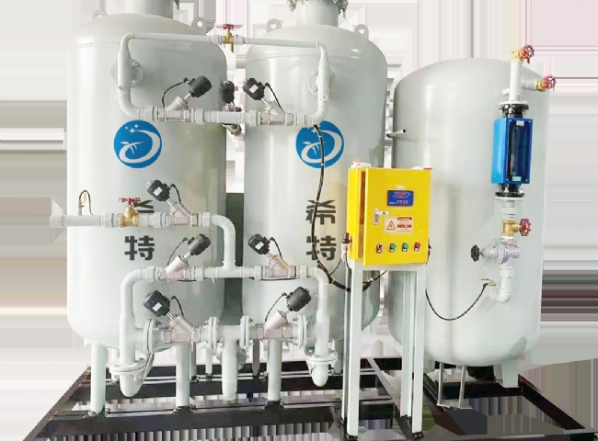

Nitrogen and oxygen are known to be life-savers. This is because， these gases have their applications in a wide range of processes.

Oxygen is used to form some chemicals such as sulfuric acid and nitric acid for industrial， chemical and medical procedures and also for welding and cutting of metals.

Likewise， nitrogen has its wide range of applications in the preparation of nitric acid， explosives， etc.

XITE fully understands the importance of these gases. Therefore， the best oxygen equipment is manufactured and quality oriented nitrogen equipment is supplied.

Applications using recirculating nitrogen equipment supplied by SCHITT

Helps to prevent the formation of rust in the boiler tubes by cleaning the boiler tubes when immersed in the cooling towers， affected by oxygen.

Used as a safety supplier in air bags

Allows smooth passage of liquids through the tubes

Helps to avoid contamination

Used to eliminate waste

Helps prepare materials for use in aerospace and aircraft

Used primarily in tires to give them long life and smoothness It also prevents leakage of gases.

Helps to prevent corrosion of aerosol systems by being used as a supervising gas

Features of the oxygen equipment manufactured by Suzhou XITE.

Provides 2 types of automation， i.e. 1w+1s.

Provides additional filtration levels

Oxygen can be generated at any time when needed

Easy to install and operate

Shows the passing arrangement with the help of rotor flow (flow) meter

Contains a separate air dryer to help reach the desired expiration point

Contains a fully automatic system to reduce time and energy.

This is the most critical decision which can hamper your industrial operations and growth.

So， choose Suzhou Schieter and rely on us for reliable and efficient oxygen and nitrogen equipment.