**Air Compressor Overheating: Causes and Solutions**

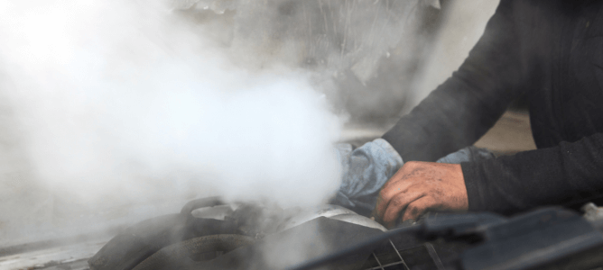

Air Compressor Overheating: Causes and Solutions

Air compressors are essential to many industries， from pneumatic tools to providing air for industrial processes. However， a common problem with air compressors is overheating. Overheating can lead to reduced efficiency， costly air compressor repairs， and even catastrophic failure. We'll look at how air compressors work， what causes them to overheat， the consequences of overheating， and signs you can look out for to prevent overheating.

How Air Compressors Work

Industrial air compressors use compressed air to power a variety of tools and equipment. They draw in ambient air and compress it using a compressor， then store it in tanks for backup. Proper ventilation is essential to prevent overheating and ensure efficient operation. Routine maintenance， including checking oil levels and lubrication， keeps air compressors running smoothly. Monitoring for performance issues， such as high exhaust temperatures， can help identify potential problems. By understanding how your air compressor works， you can optimize its performance and prevent overheating.

Common Causes of Air Compressor Overheating

Inadequate ventilation or blocked vents can restrict airflow and lead to overheating. Low oil levels or poor oil quality can increase friction and generate excessive heat in the compressor. High ambient temperatures， especially in the summer， can also lead to overheating. Mechanical problems such as worn components or malfunctioning thermal valves can also lead to excessive heat buildup. In addition， a lack of routine maintenance (e.g.， not cleaning air filters and condenser coils) can reduce cooling efficiency.

Consequences of Overheating

Overheating can have serious consequences for an air compressor. It can damage internal components and significantly shorten the life of the compressor. Overheating can lead to reduced performance， decreasing air output and compressor efficiency. Additionally， overheating causes the oil to break down， which increases friction and accelerates the wear of compressor components. This affects overall functionality and increases energy consumption and operating costs.

Signs of an Overheating Air Compressor

When an air compressor begins to act abnormally， it is important to remain vigilant at all times. This way， you can avoid unnecessary downtime or any loss of production. Watch out for the following signs that will tell you when your compressor is overheating.

Abnormal noise levels

Abnormal grinding or rattling noises while the compressor is running may indicate overheating. It is important to be aware of sudden changes in noise levels as they can signal mechanical failure. Regular monitoring of noise levels can help identify potential overheating problems before they escalate. If the unusual noise persists， turn off the compressor and check for mechanical problems.

Elevated discharge temperatures

Low refrigerant levels or poor lubrication can lead to high discharge temperatures. Checking these temperatures regularly will help prevent damage to internal compressor components. If the discharge temperature continues to rise above the normal operating range， the cause must be investigated and immediate steps taken to solve the problem causing the rise in discharge temperature.

Frequent Shutdowns Due to Temperature Limits

When temperature limits are reached， the air compressor may shut down frequently. These temperature limit settings are built-in safety features designed to prevent overheating. Overheating is clearly indicated when the compressor repeatedly stops due to temperature limits. The automatic shutdown feature helps prevent further damage and allows the compressor to cool down. It is important to investigate potential causes， such as inadequate ventilation or mechanical failure， to resolve the problem.

Abnormal vibrations

Abnormal vibrations during compressor operation may indicate an overheating or mechanical problem. These vibrations may indicate misalignment， component wear， or imbalance within the compressor. Addressing and resolving the cause of these vibrations can prevent further damage to the compressor. Daily monitoring of vibrations as part of routine maintenance will ensure optimum performance.

Preventive Measures

To prevent an air compressor from overheating， it is vital to carry out routine maintenance. Regularly check the oil level and lubricate the compressor to ensure optimal performance. Another preventative measure is to clean the air filter to maintain air flow and prevent overheating. Additionally， checking and cleaning the condenser coils will help with efficient cooling. Regular monitoring of the discharge air temperature can detect any signs of overheating. Finally， there should be adequate ventilation and airflow around the compressor to prevent heat buildup.

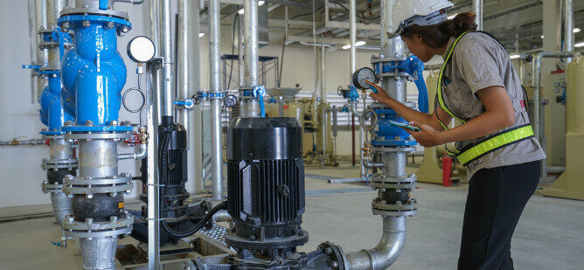

Regular Maintenance and Inspection Program

Regular compressor inspections help to detect any signs of wear or damage. In addition， clean and replace air filters regularly to ensure proper airflow. Checking for leaks in the system is also vital to prevent overheating. Finally， be sure to follow the manufacturer's guidelines for routine testing， maintenance and care of your air compressor.

Ensure Proper Ventilation and Cooling

To ensure proper ventilation and cooling of your air compressor， it is important to provide adequate airflow. Remove any debris or obstructions around the vents to allow for smooth airflow. In addition， consider using a fan or additional cooling equipment to prevent overheating in hot environments. Installing a chiller or heat exchanger can also help reduce operating temperatures. Finally， place the compressor in a well-ventilated area to promote proper operation of the air system.

Monitoring and Controlling Operating Temperatures

It is important to keep the ambient temperature within the recommended range and utilize thermal valves or temperature sensors to track and control compressed air temperature levels. Adjusting compressor settings to ensure optimal operating temperatures helps prevent overheating. In addition， utilizing an automatic shutdown feature provides additional protection against overheating.

Proper Lubrication and Fluid Levels

To prevent your air compressor from overheating， it is critical to ensure proper lubrication and maintain proper fluid levels. Regularly check and maintain the oil level in your compressor according to the manufacturer's recommendations. Always use the recommended lubricant for the specific requirements of the air compressor. Regularly monitor the quality and viscosity of the lubricant to avoid any problems. Proper lubrication of internal parts is essential to prevent friction and overheating. In addition， ensure that condensate is drained regularly to avoid moisture buildup.

Adjust pressure settings as required

By setting appropriate pressure limits， you can prevent the compressor from being overworked and minimize the risk of overheating. During periods of high ambient temperatures， consider using a lower pressure setting to relieve system pressure. To ensure proper adjustment of pressure settings， refer to the recommended values in the manufacturer's guide. This will help achieve optimum results while extending the life of your air compressor.

Troubleshooting Overheating Problems

To troubleshoot an air compressor overheating problem， it is important to identify the most common causes of this problem. Start by checking for clogged or dirty air filters， which can restrict airflow and cause the compressor to overheat. Check the exhaust lines and cooler coils for any blockages or damage. Make sure the air compressor is supplied with the proper voltage to prevent high voltage surges that can cause overheating. It is also vital to monitor refrigerant levels and address any low refrigerant or leaks that cause overheating.

Tips for Choosing the Right Air Compressor

When choosing the right air compressor， consider your specific requirements and application. Determine the horsepower and cubic (cfm) required for the application. Evaluate available space and consider compressor size and portability. Evaluate power options， such as electric， gas or diesel， based on your needs. Also， research and compare different air compressor makes and models to find the best fit for your needs.