**Hospitals should be mandated to install on-site oxygen generators to maintain an uninterrupted supply of oxygen**

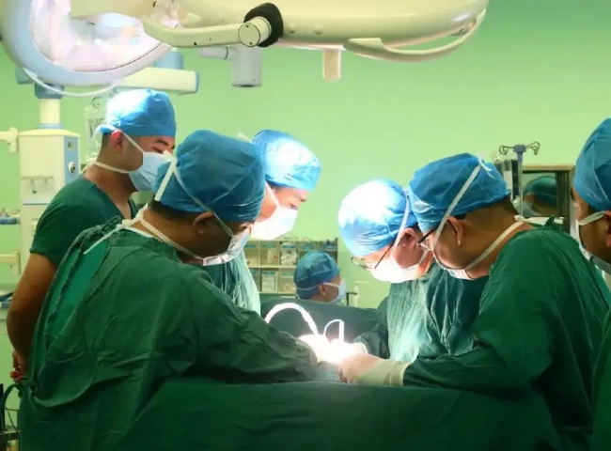

The devastating second wave of coronavirus has made the world realize the importance of medical oxygen - a life-saving resource. The pandemic has caused all healthcare systems to rethink long-term solutions for dealing with high oxygen demand. One step all healthcare organizations can take to prevent a similar tragedy from happening again is to equip hospitals with the technology and associated infrastructure to generate their own medical oxygen on site.

Among the list of options available for on-site medical oxygen generation， pressure swing adsorption (PSA) technology has proven to be one of the most practical and high-quality options available to all healthcare facilities and hospitals. This solution can also be a great addition to liquid oxygen， cylinders， concentrators and any other available option.

Onsite medical oxygen generators are no longer an option， but an obligation.

For decades， our hospitals and medical facilities have relied on oxygen supplies outside their scope， which has been a dangerous proposition. There are several reasons why authorities should consider on-site generation of medical oxygen as an alternative. The most important reason is that our transportation and logistics system is somewhat inadequate. Other reasons include the constant need for dedicated and specialized tankers， the need for constant resupply， the risk of evaporation of liquid oxygen， and， more seriously， the danger of large amounts of oxygen leaking into the air and causing fires and other consequential damage.

China has only 1，224 tankers that can carry 16，732 tons of medical oxygen. And with a turnaround time of nearly 6 to 7 days for these tankers， it is estimated that only 200 tankers are in transit at a time.

Thanks to Covid， the country's demand for medical oxygen has never been greater than in recent years. Demand for medical oxygen has reportedly increased sevenfold since the pre-Covid days. A few months ago， the country experienced a high demand for medical oxygen of nearly 9，000 tons per day. Some industries that produce or need oxygen for manufacturing processes have had to divert their resources to Covid-driven medical emergencies. In addition， despite accelerated vaccination campaigns， there are no adequate guarantees regarding the dreaded virus and its public health impact， even though the demand seems to be easing in recent days.

The difference between availability and timely distribution to those in need

At the same time， it is important to recognize that there is a clear distinction between the availability of life-saving resources and their timely release to patients in need. In the third week of April 2021， the government submitted to the Supreme Court that the liquid oxygen available in China was three times greater than the total need of the 12 states with Gokovid cases. Nevertheless， in the days and weeks that followed， several states reported shortages of medical oxygen. The problem， of course， was not so much a lack of supply as a failure to provide timely supplies to patients in need. Therefore， making this life-saving resource available in hospitals is one effective way to address this problem. It would also obviate the need for long-distance transportation and other logistical requirements.

How does PSA technology work?

PSA technology involves passing atmospheric air through a high-pressure internal filtration system that uses microporous molecular sieves or zeolites as adsorbents. The large surface area of the molecular sieve allows for the separation or adsorption of nitrogen from the air， leaving behind concentrated oxygen. This allows medical-grade oxygen to be generated and continuously delivered to patients through the hospital's existing gas piping.

What can XITE do to combat medical oxygen shortages?

This oxygen can easily be piped throughout the hospital or to nearby facilities， and it can even be transported in cylinders to smaller hospitals in the area. We could begin by setting up an oxygen generator plant at each regional hospital in the country as a hub for further distribution to other medical facilities. Alternatively， if resource constraints do not permit， as the center-state argument suggests， we could start with an on-site plant serving two adjacent regions. Our goal is to start as soon as possible.

What are the advantages of PSA technology?

PSA on-site generator plants require less capital than cryogenic technology plants. Even though the initial capital for the setup may appear larger on the surface， it can be recovered by the savings in monthly oxygen bills that the hospital must pay in a few months. In addition， PSA units are easier to assemble， but they can also be up and running in a matter of weeks. They are also environmentally friendly， as they avoid long-distance transportation and thus avoid toxic emissions. According to the World Health Organization's technical specifications， all medical PSA oxygen generator equipment is a source capable of producing medical-grade oxygen on a large scale 24 hours a day， 7 days a week， which means the technology is inherently reliable. To be sure， PSA oxygen concentrator equipment requires trained personnel and ongoing maintenance.

However， these are prerequisites for any technology. another important advantage of PSA technology is its ability to produce medical grade oxygen within minutes of being turned on.

Very high purity is not required

For oxygen used for medical purposes， a particularly high purity of 99% concentration is not required. Medical oxygen purity of 93% (3%) is permitted worldwide. While liquid oxygen is purer， given the supply and delivery bottlenecks in our country， it is better for our hospitals to have some oxygen on hand rather than to have the highest quality oxygen that is only available for a limited time and is unreliable.

In short， the need for our hospitals to install on-site oxygen generator equipment to replenish liquid oxygen cannot be overemphasized. The government's announcement that 551 PSA production will be built nationwide， in addition to the 162 PSAs already announced， must be embraced by all. The government must act quickly on this statement.

In fact， the government should go further and make it mandatory for large hospitals to use on-site medical oxygen generators， keeping in mind that Covid-19 still exists.