**China Air Separation Gas Industry Development Overview**

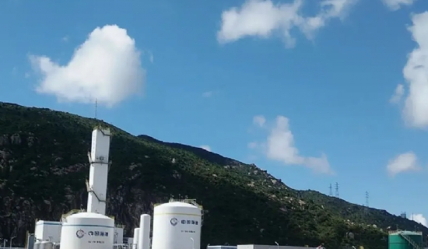

1、China's air separation gas industry is developing rapidly with great potential

China's industrial gas industry is developing rapidly， with the market size growing rapidly from RMB 37.4 billion in 2010 to RMB 49.4 billion by the end of 2013， with an average annual growth rate of more than 9%. Although China's industrial gas industry has gained significant development in the past 10 years or so， there is still great potential for future development. Compared with developed countries， China's per capita industrial gas consumption is still at a relatively low level. According to the per capita consumption of industrial gases in 2007， China's per capita consumption of industrial gases is only 1/26 of that of the United States， less than 1/20 of that of Western Europe and Australia， and there is also a big gap with South America and Eastern European countries， so there is a broad development prospect.

It is expected that in the next five years， with the continuous growth of China's economy and the expansion of the breadth and depth of air separation gas applications brought about by economic restructuring and industrial upgrading and transformation， China's air separation gas market will still maintain an average annual growth rate of more than 9%， and the market size is expected to reach about 69.4 billion yuan in 2018， accounting for 10% of the global market share.

2. Non-marketed gas supply accounts for a relatively high proportion， and outsourcing gas supply is developing rapidly

The international demand for corporate air separation gas is basically met by professional suppliers. Following this industry development trend， China's industrial gas outsourcing has developed rapidly in recent years， with the proportion increasing from 41% in 2007 to 49% in 2010， but far below the 80% outsourcing ratio in developed countries， which is expected to gradually increase to 55% by 2015. Outsourcing the gas production process can save large one-time equipment acquisition expenses for gas-using enterprises and effectively improve the efficiency of their capital use. In addition， outsourcing auxiliary operations can help companies focus on their core business and diversify risks. At the same time， the more professional gas operation capability of gas supply enterprises will effectively improve the quality of gas supply.

3. Insufficient comprehensive utilization and prominent energy waste

In 2010， the proportion of self-made air separation gas in China was about 51%， and a large number of enterprises still met gas demand by building their own air separation equipment. Due to the difference between the actual output of air separation equipment and the gas demand of enterprises， coupled with the influence of unstable gas supply， the comprehensive utilization rate of enterprise equipment is low， and the products that cannot be consumed in the current period are mostly emptied， resulting in prominent waste of resources.

In addition， many small-scale air separation gas demand enterprises in China are still using small high-energy consumption air separation equipment to make gas， a serious waste of energy. Relevant research data show that the energy consumption per unit of professional large-scale air separation equipment (oxygen production >5，000m3/h) is only about 1/2-1/3 of that of small equipment (oxygen production <1，000m3/h)， and has the advantages of high reliability， low maintenance cost and long trouble-free operation time.

4、The strength of domestic enterprises is gradually increasing and the market competition is fierce

Foreign gas suppliers have entered the Chinese market since the 1980s， and have rapidly occupied the domestic on-site gas production market by virtue of their strong capital strength and rich experience in project operation. With technological progress and industrial transformation and upgrading， local Chinese companies

Gas companies represented by Yingde and Hangxiang have also joined the large-scale， low-energy， high-level international competition and have occupied a certain market share in the Chinese market. In recent years， especially large-scale coal-to-oil and coal-to-gas projects have been launched in China， and the competition between local industrial gas companies and international gas companies has become increasingly fierce in the major gas business of large-scale on-site gas supply.

5. The retail market is regionally segmented and in need of integration

In the retail market of air separation gases， since the development strategy of foreign companies in China is mainly located in the on-site gas production market， and the retail market requires strong supply assurance and localization service capability of suppliers， domestic gas suppliers， especially regional superior suppliers， have natural competitive advantages.

Since the retail gas market has emerged late in China， the market is not yet saturated， and the retail market is highly territorial， there are a large number of small and medium-sized gas distributors in each region， and the dominant suppliers in the region are still busy expanding their production capacity and capturing the market， with insufficient incentive for regional integration and cross-regional expansion.