**Compressed air dryer and high quality clean compressed air**

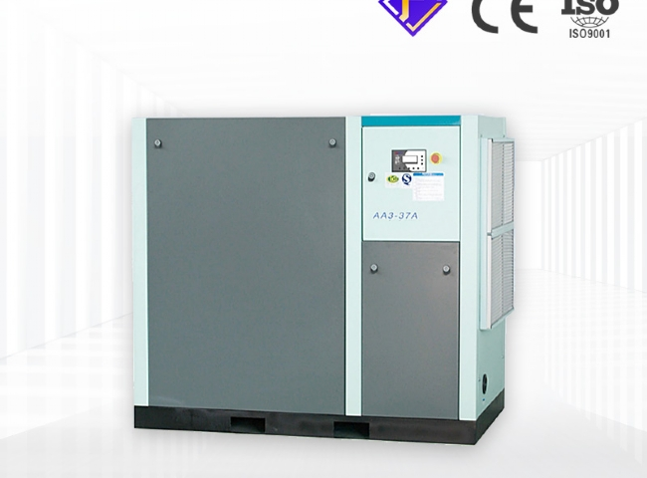

This is especially important for those associated with industry. This is because there are many operations performed in industry that involve the use of compressed air， containing harmful dust and impurities.

Air dryers are designed primarily to remove impurities and water vapor from compressed air that can subsequently lead to erosion of pipes and non-functioning pneumatic systems. These devices are used in industries such as textiles， chemicals， mining， paper processing， telecommunications， sanitation， and aviation.

They are produced in large quantities and are flexible enough to operate at extreme temperatures to provide clean compressed air for operations.

XITE offers different types and specialties of trustworthy air dryers. You can choose the category according to your needs.

* Diversion dryer: Here wet air is used， which is passed through a heater to improve moisture retention.
* Heatless Air Dryer. It has fully automated features. It uses adsorption method to dry the moisture content and uses less electricity. It is compact and reasonably priced.
* Refrigerator dryer: It is capable of lowering the temperature for better moisture removal. It can be used for all quantities of capacity. It is highly operable and has low operating costs. Moreover， it prevents undesired noise.
* Internal heater type dryer: It uses external heaters to raise the air temperature from 40 - 450C to 1800C， where high and low temperatures are used for restoration purposes. It is the simplest and the most solid.
* Biogas dryer: It works at an inlet temperature of 40 - 450C to eliminate unsafe water vapor.