Application of industrial oxygen generator in metallurgy and metal processing

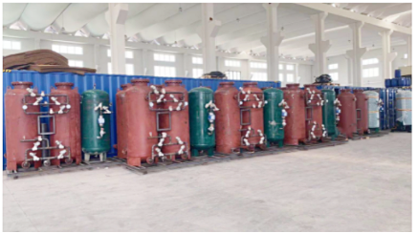
1、 Application of industrial oxygen generator in iron and steel metallurgy industry:
l) Oxygen top blown converter steelmaking: in 1952， Austria invented oxygen top blown converter steelmaking， which is characterized by short smelting cycle (1 / L6 of open hearth furnace)， large output and low energy consumption， thus promoting the rapid development of iron and steel industry.
2) Blast furnace oxygen enriched blast ironmaking: blast furnace oxygen enriched blast (supplemented by pulverized coal injection) ironmaking can improve furnace temperature， reduce coke ratio and increase output. When the oxygen content in blast furnace is increased by 1%， the iron output can be increased by 4% - 6% and the coke ratio can be reduced by 5% - 6%. When the oxygen enrichment is 3% - 4%， the oxygen consumption per ton of iron is 45.
3) Electric furnace steelmaking: electric furnace oxygen blowing steelmaking can shorten the melting time， reduce heat loss and reduce unit power consumption. Oxygen blowing per ton of steel can save electricity skw · h， and the unit oxygen consumption of electric furnace steelmaking is 40m3 / T.
4) Smelting reduction process (COREX) ironmaking: This is a new iron making process that has not been popularized. It replaces the three-stage production process of sintering， coking and blast furnace， which can reduce production cost and pollution. However， the oxygen consumption per ton of iron is as high as 530 ~ 550m3， which is 10 times that of oxygen top blown converter steelmaking.
5) Steel processing: during steel processing， continuous casting， flame cutting， cleaning， etc.， the oxygen consumption per ton of steel is 10-12m3.

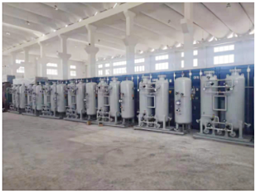
2、 Application of industrial nitrogen generator in metallurgical plant:
1) Nitrogen is mainly used as sealing gas， conveying gas， protective gas， stirring gas， purging gas and instrument gas in metallurgical plants. At present， the proportion of oxygen and nitrogen consumed by metallurgical plants is about 1: 1. Moreover， the amount of nitrogen still has an upward trend， which should be properly reserved in the design.
In addition， argon is used for stainless steel smelting， argon blowing in ladle， sealing of ladle and tundish nozzle， protective gas， etc. At present， the argon consumption of metallurgical plants is still small， and about 3-4.5m3 argon is consumed per ton of steel.
Generally， the allocated air separation equipment extracts argon products in full amount， and the surplus is exported.

