**What is the purity of high purity gas? Hitler told you**

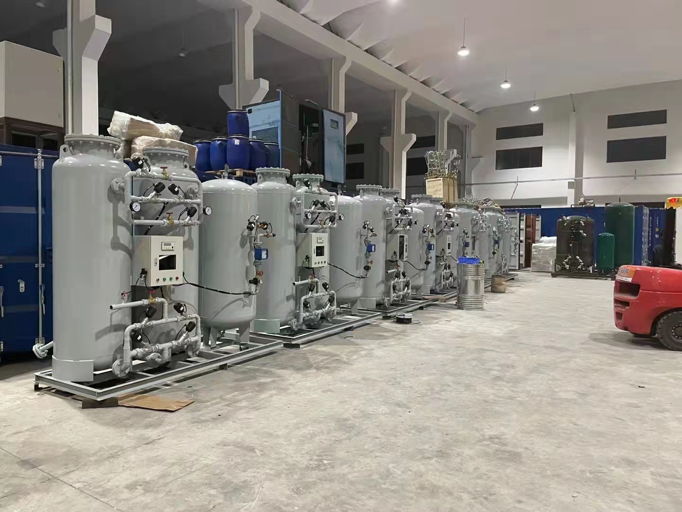

High purity gases usually refer to gases with a certain level of purity that can be achieved by using modern purification technology. For different types of gases， purity indicators are different. For example， for nitrogen， hydrogen， argon and helium， it usually refers to high-purity gases with purity equal to or higher than 99.999%; For oxygen， the purity of 99.99% can be called high purity oxygen; For hydrocarbons， the purity of 99.99% can be considered as high-purity gas.