**Companies all over the world are using oxygen-nitrogen equipment made in China.**

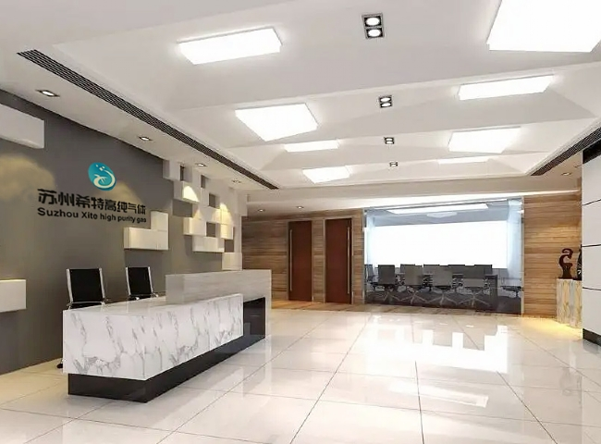

Oxygen-nitrogen equipment is being designed， developed and manufactured all over the world. The authenticity， durability and quality of these devices must be checked. This equipment produces both oxygen and nitrogen. The productivity of two machines can be satisfied by one oxygen-nitrogen equipment. When buying， oxygen and nitrogen generators， take into account the following features: - low maintenance， low energy consumption， pure production， compact and robust design.

China produces a large number of high quality oxygen and nitrogen generators. It is one of the most trusted suppliers of nitrogen equipment in the world. Suzhou Schieter， China produces durable plants with 99.7% pure oxygen and 99.99% pure nitrogen. Every part of the plant is carefully checked and ordered from Italy. Companies choose their plants according to their requirements. Some companies produce large quantities of oxygen and nitrogen， so they need huge oxygen generators， while others need small generators.

It is now possible to buy online it is recommended to actually look at the oxygen and nitrogen generators before buying them， but many companies have formed to order online. Suzhou Seagate in China is one company that will not leave its customers unsatisfied. It produces oxygen and nitrogen generators with capacities ranging from 20 m3/h to 5000 m3/h. If you don't know which equipment is best for your company， the professionals at China Suzhou Schieter will guide you. They will perform a detailed analysis of your requirements by asking you a series of questions， after which they will recommend the perfect oxygen and nitrogen generator for you.

Buyers from all over the world cannot come to China until they know who the manufacturer is， what kind of equipment is produced and other technical details. In this case， the best solution is an online search. It gives you a list of manufacturers and a catalog of the machines they produce， and you can even look for reviews， compare and pick out the right machine for your requirements. Suzhou Schieter China manufactures a range of machines such as oxygen and nitrogen generators and also offers help in selecting them. They are known for their customer satisfaction and for being the best supplier of nitrogen equipment in China.