**Cryogenic oxygen generators producing the purest oxygen gas**

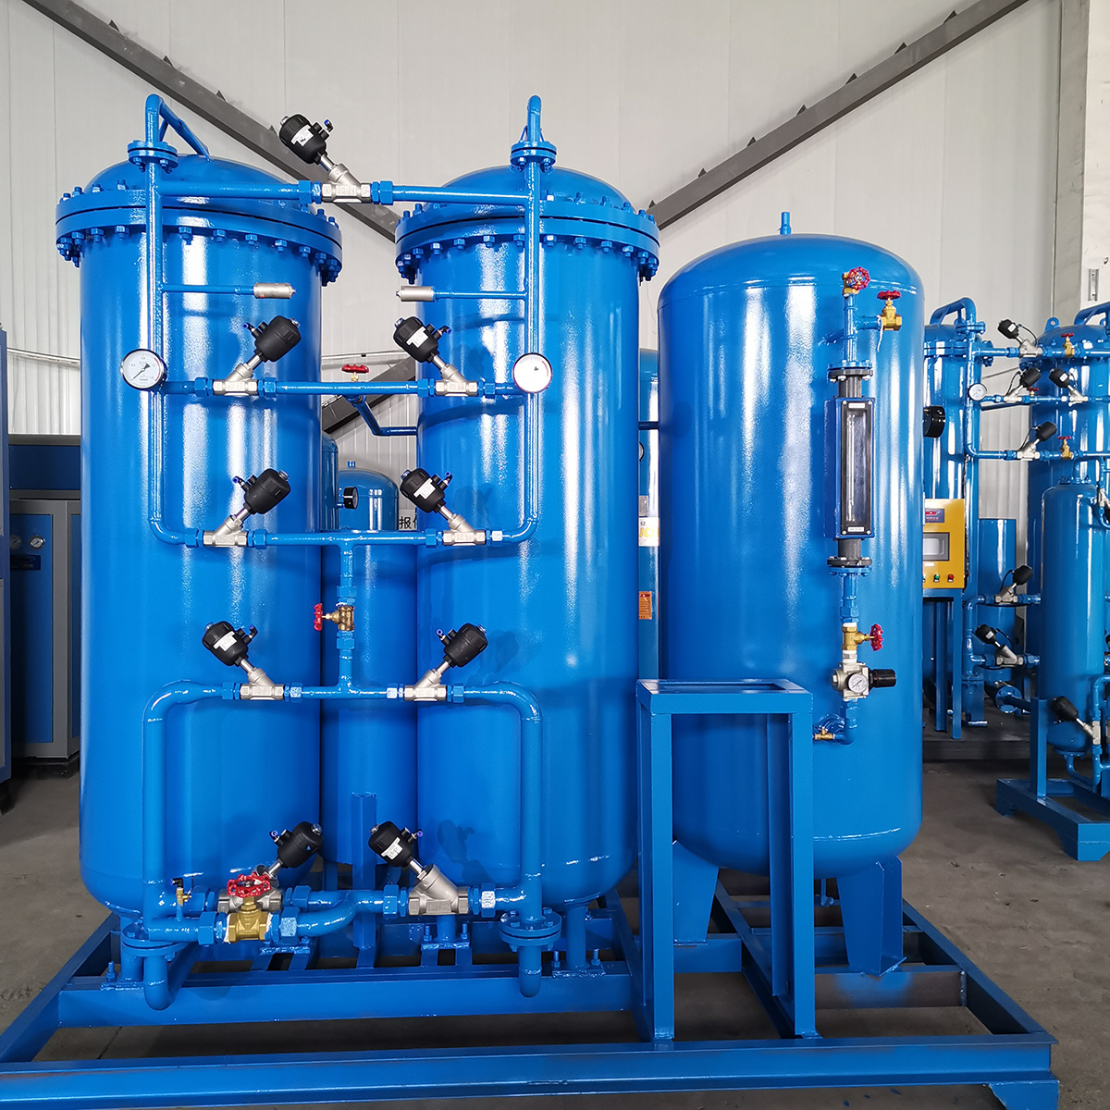

Industry has an excellent option for generating pure oxygen gas. The name of this new technology is cryogenic technology. It is a world-famous and very useful technology that extracts oxygen gas from air.

Why should you choose it?

Well， these oxygen generators use a fully automatic rotary air compressor and operate at the lowest possible pressure， down to 6 to 8 bar. Cryogenic oxygen generators also offer many other features such as high output， error-free operation， low maintenance costs and low energy consumption.

This cryogenic oxygen generator equipment provides high purity oxygen up to 99.7% and nitrogen up to 99.99% pure. Therefore， you can choose this equipment for all your industrial oxygen and nitrogen needs.

With these features， you will be assured of the purest oxygen for your requirements at a very low cost. On top of this， maintenance costs are low， so you should be able to reach the break-even point very early on.

Manufacturers of Cryogenic Oxygen Concentrators

There are many manufacturers in China and around the world who manufacture and supply these units at low cost. But you should choose your company very carefully， because along with low prices， you must not forget about quality. Here， remember that you should always buy such products from a CE certified supplier to guarantee durability and robustness.