**Air compressor anatomy 101**

    We have fault diagrams and diagrams of piston air compressors (reciprocating， also known as "recip") and rotary screw air compressors. There are other types， but the vast majority of air compressors used today are one of these two types. Usually， they are composed of air pump， motor or engine and tank for storing compressed air.

The air compressor has many different parts and components. Although some may be universal， most parts will vary depending on the brand and model of the compressor.

In the market， some commonly used compressor brands. Many of their parts can be common to each other， such as check valves and filters. However， most parts will be specifically designed for this air compressor. In the following sections， you will find exploded views of some of the most popular compressor components and some of their possible differences depending on the manufacturer.

## **Piston air compressor**

Piston compressors (also known as reciprocating compressors) use pistons driven by the crankshaft to deliver high-pressure air. The following image with faults shows the most prominent components of the compressor. The figure on the left shows the standard stationary compressor (Ingersoll Rand ss5l5)， while the figure on the right shows the (rolair) trolley compressor， which is designed to be carried on site.

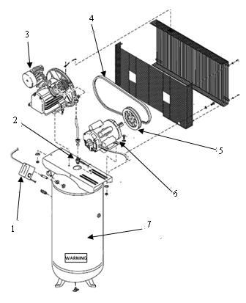

1. Pressure switch
2. Check valve
3. Compressor pump
4. Belt
5. Pulley
6. Motor
7. Tank

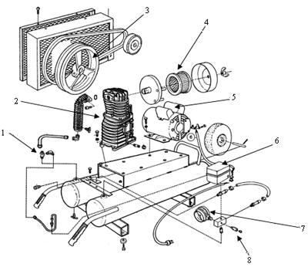

1. Check valve
2. Compressor pump
3. Pump flywheel
4. Air filter
5. Motor
6. Pressure switch
7. Instrument
8. Safety relief valve

## **Screw air compressor**

Rotary screw is a kind of compressor， which uses two meshing helical rotors to capture a certain volume of air and then compress it to a higher pressure. Screw compressors can operate at lower temperatures and can operate 24 hours a day， 365 days a year. These compressors are fixed and usually have a specific air piping system through its warehouse， industrial plant or store. Many local stores we see also use ordinary air hoses because of their flexibility and mobility.

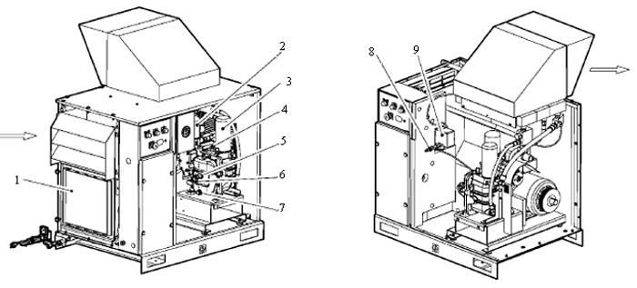

1. Integrated dryer (optional)
2. Coolant filter
3. Coolant separator element
4. Main engine safety valve
5. Coolant filter plug
6. Mirror
7. Pilot valve
8. Pressure switch