**More and more customers are using on-site hydrogen generators to produce hydrogen**

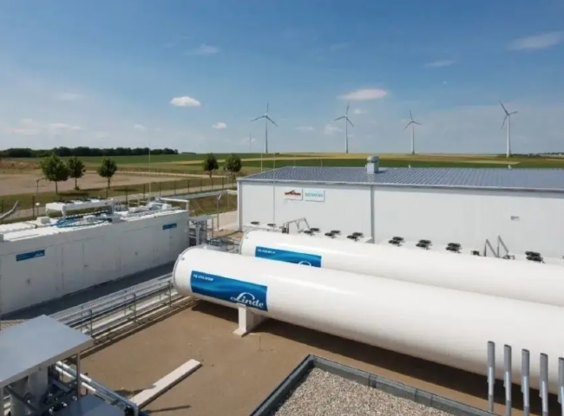

Today， hydrogen plays a very important role in a variety of industrial applications. The purity of hydrogen， reliability of supply and ease of use are the primary considerations when selecting various supply methods.

In the past， hydrogen equipment was considered an asset for those who had the technical expertise to operate and maintain the equipment. A number of statutory guidelines to be followed and required licenses made hydrogen equipment less attractive to users， thus making the use of cylinders popular. This is still the case in China， where many customers are still skeptical about installing their own on-site hydrogen equipment.

With the advancement of hydrogen production by water electrolysis using proton exchange membranes (a non-alkaline and very safe technology used in aerospace， power plants， heat treatment industries， etc.)， it has become very convenient to have a hydrogen production system that can be easily and efficiently operated， allowing them to achieve the required parameter accuracy.

XITE offers hydrogen generators using PEM technology.

PEM technology uses a solid polymer electrolyte (SPE) membrane， so it acts as an electrolyte， facilitating the electrolysis process， and as a membrane， separating oxygen and hydrogen. This is a very safe system， as the oxygen generated at low pressure cannot be mixed with the hydrogen at high pressure due to the differential pressure design.

As a result， the Proton Hydrogen Generator can be easily installed in any industry where purity， dew point and supply reliability are important. Smaller benchtop models are also available to meet the needs of laboratories (forensic， environmental， pharmaceutical， etc.).

With the advent of PEM technology， customers are increasingly abandoning cylinder supply in favor of Proton's compact on-site hydrogen generators. Some of the many reasons why customers are choosing them are

Economical

Ease of use

Reliable supply

Compliance with the necessary parameters for the gas

safety

peace of mind

In some critical applications of hydrogen， the above parameters play a crucial role in the decision making process for the selection of the supply medium， some of which are.

Gas chromatography

annealing

Sintering

Metal coating

Reduction of metals. And so on.

Technological advances in the on-site hydrogen production process are leading to a mental paradigm shift and are replacing hydrogen cylinders fairly rapidly.