**Application of nitrogen generator in laser cutting field**

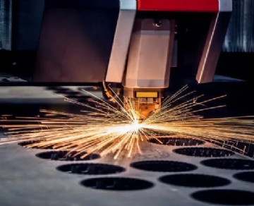

The nitrogen generator is extremely beneficial to the manufacturing business and enterprises that provide precision laser cutting services. The use of nitrogen in the laser cutting process helps to reduce the oxidation of the metal surface and provides faster and cleaner cutting.

Laser cutting with nitrogen generator

Using nitrogen in your laser cutting process can help you achieve accurate and optimal cutting on metal， glass， ceramics and other types of materials. Nitrogen keeps oxygen away from the cut， preventing discoloration， charring， and burning. In addition， materials laser cut with nitrogen are more likely to pass the bend test after welding， and the risk of paint adhesion failure is lower.

Benefits of laser cutting using a nitrogen generator

Nitrogen is non flammable and does not interact with laser beams or cutting surfaces， so it is very suitable for use with laser cutting and welding machines.

These are just some of the benefits of using a nitrogen generator in the laser cutting process:

Replace the oxygen around the incision to reduce the risk of combustion， charring and oxidation

Remove molten metal from the cutting path

Compared with renting nitrogen bottles， it can reduce the cost of laser cutting and improve the return on investment

Allows precise control of nitrogen purity levels

Reduce nitrogen waste

Provide a continuous supply of nitrogen