**Practical experience in the application of aeration (dissolved oxygen) in shrimp culture**

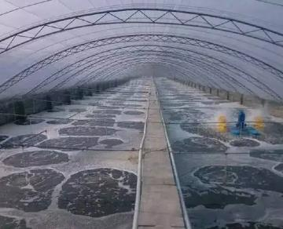

Pond aerators and water movers play a key role in establishing the ideal culture environment for shrimp in large ponds. They are mainly used to maintain adequate oxygen levels and gas exchange. They also maintain good mixing of pond water， prevent stratification and keep water quality consistent throughout the pond. The circular flow of water produced by the aerators also concentrates slowly settling wastes (such as slits， algae and manure) into the center of the pond， creating a sludge pile that you will see when you finally drain the pond at harvest time. In a 1 ha pond， this mound should ideally be less than 40 m (1200 m) in diameter. Faster water flow around the perimeter of the pond will clear the bottom of the pond so that this feeding area is free of excess organic debris. The aerator can be installed in place with high stakes hammered into the mud or secured to the bank with long ropes. The layout of the pond aerator should be designed to achieve maximum pond water flow with minimal energy input. In square ponds， using a minimum of four aerators， each positioned 15-18 from each side at each corner， will provide sufficient water to the aerator and minimize scouring of the bank.

One of the most common mistakes is to place the paddle-wheel aerators too close to the bank or corners where it is believed that the water is tracking past in a general circular pattern. Directing the flow of water through the path of another aerator should be avoided， as this can create eddies and deposit waste beyond the center. Positioning in odd shaped ponds needs to be done on an individual basis， possibly by trial and error.

Key instructions for improving aeration management.

Use aerators at stocking densities above 30，000/ha. The use of aerators in ponds can have a significant impact on the maximum production achievable from a pond. Dissolved oxygen (DO) concentrations should exceed 4 ppm. use aerators if concentrations fall below 4 ppm at night and early in the morning. If the oxygen level in the pond drops， shrimp will begin to swim near the surface， especially in the early morning hours.

Use an aerator of 1 hp for every 400 kg increase in the biomass of shrimp in the pond. For large ponds with less than 500 kg of biomass， the aerator is not needed. Fix the aerator at least 3 m away from the dike. Keep the speed of the aerator at 80-100. position the aerator correctly and operate it efficiently to reduce erosion of the pond dike and suspension of sediments at the bottom of the pond.

The location and direction of the aerator (clockwise) should encourage maximum water flow in the pond. It should be sufficient to concentrate waste in the center of the pond. Aeration can be used when applying lime fermentation juice to the water. Stop aeration during feeding and trailing.

If dissolved oxygen levels drop below 3 ppm due to any mismanagement or equipment failure， first increase mechanical aeration and as a last option perform water changes. Aeration is usually required between late evening and early morning after 30 days of culture. Regular aeration is a better practice. In farms with low stocking densities， low dissolved oxygen is mainly due to organic waste at the bottom of the pond， especially unremoved sludge， dead benthic algae and overfeeding. In such cases， aeration should be provided when shrimp begin to surface or when the bottom soil quality is poor and the water has more turbidity and dark color.

It is recommended to operate an aerator in shrimp ponds.

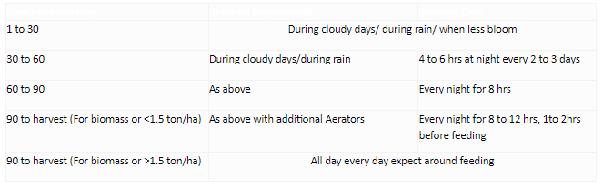

Poor placement of aerators in a pond can lead to erosion of the pond walls or bottom and greatly increase the amount of sediment in the sludge pile at the end of the crop. This can reduce the life of the pond and increase maintenance costs.

The oxygen transfer efficiency of an aerator， expressed in kilograms of oxygen transfer per kilowatt hour of power applied to the aerator shaft， is shown below for the basic types of aerators.

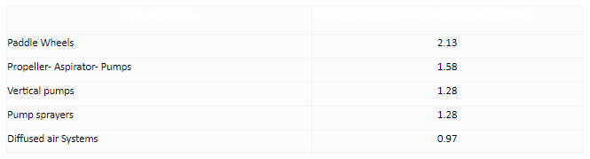

The purchase price of the different types of aerators does not vary much in terms of motor size per kilowatt. Therefore， the cost of transferring oxygen to pond water is lower for paddle aerators than for other types of aerators. However， all types of aerators have been used successfully in aquaculture.