**Difference between aftercooler and intercooler**

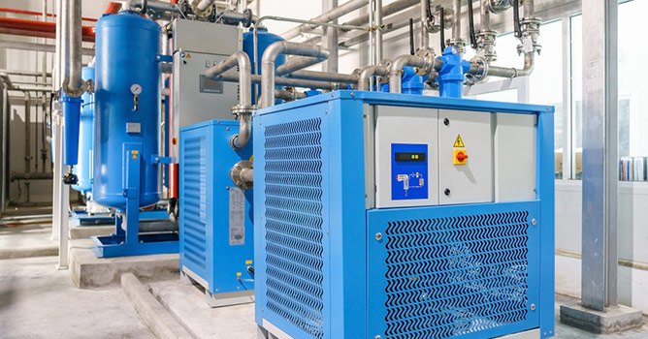

Many industrial processes require compressed air. Unfortunately， air compressors generate a lot of heat that must be dissipated to prevent damage to sensitive equipment parts.

Operators can mitigate the thermal effects of air compression by using devices such as aftercoolers and intercoolers. This article describes the differences between aftercoolers and intercoolers.

Intercoolers and Aftercoolers for Air Compressors

Properly using the name heat exchanger can prove tricky for the inexperienced operator. While intercoolers and aftercoolers are often used interchangeably， they refer to machines with subtle differences in design and operation. We clearly define the difference between intercoolers and aftercoolers.

What is an intercooler?

An intercooler is a heat exchanger whose function is to remove heat from the air produced by an air compressor. An efficient intercooler will bring the temperature of the compressed air back to near ambient levels.

How does an intercooler work?

Intercoolers are typically used in turbocharged engines to provide cooling to compressed air before it enters the engine cycle. By acting as an intake air cooling unit， an intercooler can improve the overall efficiency and power output of an engine by increasing the density of the air supplied to it.

What is an aftercooler?

An aftercooler is a mechanical cooling device that works by exchanging heat between two media， usually water and air. An aftercooler can be used to bring compressed air to a temperature of 5-20°F immediately after it is released from the compression unit.

How does an aftercooler work?

A standard aftercooler unit consists of a tube (containing water or air) and fins that help it achieve cooling. During operation， ambient air is pulled into the aftercooler to help remove moisture from the compressed air through condensation while reducing the process temperature to a satisfactory level. Compressed air aftercoolers are manufactured in either water-cooled or air-cooled form.

With air-cooled compressed air aftercoolers， ambient air is directed to a tube containing hot compressed air， removing the heat generated during the heat exchange process. In the water-cooled type (also called air-water cooler)， water is cooled by passing through a pipe that runs with the compressed air piping.

What is the difference between an intercooler and an aftercooler?

Although aftercoolers and intercoolers can be used to refer to the same equipment and function in the same way， there are very subtle differences in how they are used. An aftercooler is a heat exchanger that operates by cooling the air coming out of the compression unit， while an intercooler is a device connected to an air compressor that cools the air before it is fed into the engine.

Benefits of using a compressed air cooler

By design， both the intercooler and the aftercooler will result in the cooling of the compressed air by removing the heat generated during the compression of the air. The effect of this heat exchange is the condensation of water vapor suspended in the air， which can be collected， allowing dry air to enter the supply process. The elimination of water will protect moisture-sensitive components and prevent equipment damage that could be caused by moisture-induced corrosion.

How do I choose an aftercooler versus an intercooler application?

As mentioned earlier， aftercoolers and intercoolers have similar functions and can be used interchangeably. Depending on the target application， either type of cooling equipment can be used to remove heat from industrial processes. For applications where cooled intake air is critical to engine function， an intercooler is recommended.