**How to use oxygen generator to produce oxygen**

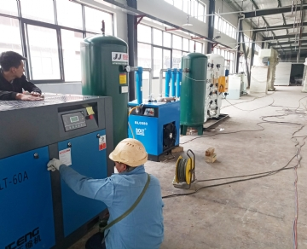

Innovative pressure swing adsorption (PSA) technology can be obtained through field gas system. PSA is a mature method of producing oxygen by using oxygen production system. Any company that buys two or one bottles of oxygen a week will benefit from the oxygen generator system (oxygen generator).

Economic alternatives using external suppliers

PSA technology is an economical alternative to purchasing oxygen cylinders from external suppliers. The oxygen generation system provides stable cost from one year to the next year; In addition， the oxygen generation system provides a rapid return on investment for the company (usually within 12 to 18 months).

Convenience: one click oxygen

The on-site gas system customizes the oxygen production system to meet the needs of each customer.

The purity of the oxygen generation system can be controlled between 95% and 99%:

Aquaculture， laboratories， cutting， fish farms， hatcheries， acetylene cutting / welding， brazing， spraying， jewelry manufacturing， hospitals， medical centers， veterinarians， first responders (firefighters， first responders， etc.)， glass blowing， wastewater treatment， ethanol production / biofuels

The portable oxygen generation system， which can be obtained by erecting a gas system (oxygen generator) on site， makes it very easy to deliver oxygen wherever needed.

Oxygen generation system - production process

Compressed air is forced through the first container. When compressed air is forced through， the sieve (zeolite) captures nitrogen and allows oxygen to pass through. Oxygen is collected and stored in an oxygen buffer tank. When the sieve in the first container is filled with nitrogen molecules， it releases nitrogen; At the same time， the second sieve bed repeats the process. This ensures an unlimited and continuous supply of oxygen.

No surprises - the cost is the same every year

Most companies get a return on investment (ROI) within 12 to 18 months of purchase. When a company produces its own oxygen， it does not need to consider delivery fees， long-term contracts， tank rents or price increases.

Use (oxygen generator) oxygen generation system to reduce operating costs

Limited maintenance and high oxygen air ratio keep the operating cost of the oxygen generation system at a normal level.

1. Fully automatic

2. When the system senses the demand of the lower system， oxygen production begins.

3. The intelligent system of the oxygen generator will ensure the safe production of the oxygen generation system.

4. Low working pressure

5. Non hazardous storage