Customized 450M3/H capacity gas dryer for chemical processing industry (3 units)

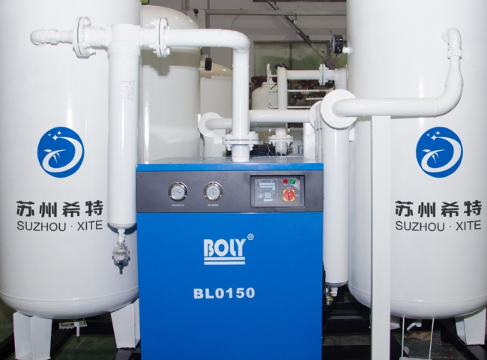
XITE， has many years of industry experience in the manufacture of gas generators， gas dryers and air dryer equipment.
We are fortunate to be able to establish business relationships with large companies in the chemical and process industries. We have recently supplied 1 air dryer and 2 chlorine unloading dryers to a leading chemical manufacturing company in Northern China. Earlier， we have supplied 2 nitrogen generators. They have been operating steadily and we are grateful for their continued trust in XITE. We are proud to give continuous support through our PSA nitrogen generators.
The specifications of these XITE gas dryers are as follows: ------.
Dryer capacity: 450 M3/h (each)
Dew point: (-) 55?C
Gas delivery pressure: 12-15 Barg

