Why use water electrolysis to produce hydrogen?

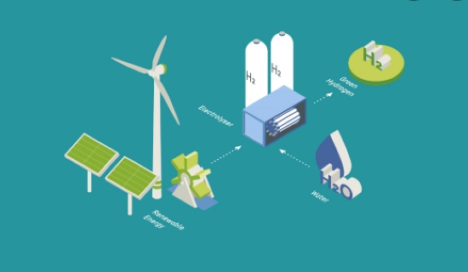
Hydrogen is essential for a variety of industrial uses. This lightest gas can be produced in different ways from a wide range of compounds. However， water electrolysis is the most popular method in all industries.
Therefore， Soochert designed the electrolysis chamber by using bipolar high pressure technology， which allows water to be decomposed into hydrogen and oxygen as soon as an electric current is passed through it. This process has many advantages compared to other hydrogen production procedures.
Advantages of applying water electrolysis in hydrogen production
Water is abundant - Since our planet is mostly made up of water， there is never a shortage of water to perform the electrolysis process. However， only deionized water can be used for the water electrolysis process in the XITEch project. Therefore， water is specially treated to deionize it before entering the electrolysis chamber.
Inexpensive procedure - The electrolysis chamber is made of very inexpensive materials， where deionized water is the electrolyte and two electrodes are used to break down the water. Therefore， it is the cheapest hydrogen generator that XITE produces and is cost effective for the customer.
Large quantities of hydrogen - XITE is manufacturing these hydrogen plants based on water electrolysis with a production capacity of 0.25 m3/h to 500 m3/h. Such plants are selected according to the production capacity required by the customer. If someone needs more hydrogen production， two or more units can be connected to achieve the required capacity.

