Nitrogen generator for oil and gas industry with 98% purity， 6KG/CM2 working pressure and 17m3/h power

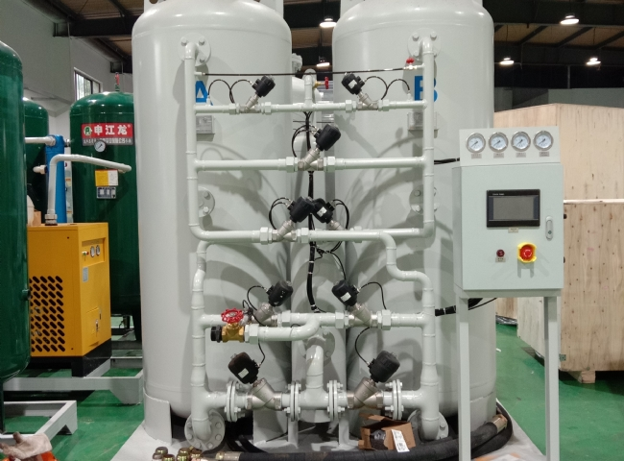
Suzhou XITE installed a 17 m3/h nitrogen generator with 98% purity and 6 KG/CM2 working pressure for the oil and gas industry.
Suzhou XITE is a manufacturer of nitrogen generators typically used in the oil and gas industry for applications such as well insulation and drainage， injection and pressure testing. Nitrogen can also be used to flood marginal fields in some enhanced oil recovery projects， more commonly using water flooding or chemical/surfactant flooding. The purity requirements of the nitrogen used depend on the requirements of the field and， most importantly， eliminate the risk of explosion and fire. In oil industry production， nitrogen is typically used at high volumes and pressures with a purity of at least 95% for pipeline filling to keep the pipeline open and for well injection to push product to the wellhead for extraction. Low pressure applications include pipeline cleaning to maintain an inert atmosphere during maintenance， cleaning of control devices， inerting of flare gases， and most commonly， gas or tank capping.
The range of products marketed by Suzhou XITE for the oil and gas industry are
Model | Capacity m3/h
XTFD-15 | 17 m3/h

