Application and conditions of high purity nitrogen generator in electronic industry

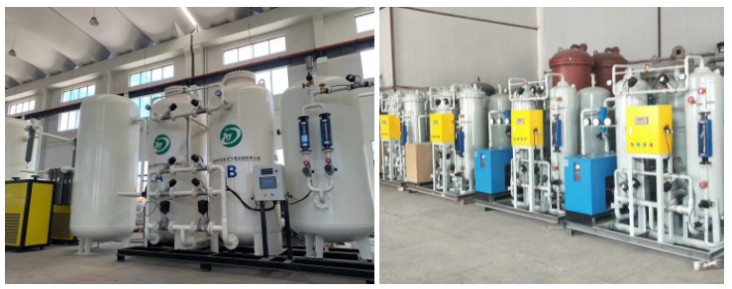

Nitrogen generator for high-purity SMT electronic assembly industry and application nitrogen generator for high-purity semiconductor industry

High purity nitrogen is also an indispensable basic raw material in the electronic industry. The purity of nitrogen in the electronic industry must be maintained above 99.999% in order to meet the production standards of the electronic industry.
SR ultra high purity nitrogen generator produces 95% ~ 99.999% high purity nitrogen， which is selectively welded， purged and encapsulated with nitrogen. Scientific nitrogen inert protection has been proved to be an essential and important link in the successful production of high-quality electronic components.
At this stage， the state has put forward new regulations for the production of the electronic industry， and the electronic components must ensure that the products do not contain lead. Therefore， most electronic industries use high-purity nitrogen for industrial production， the lead content in electronic parts is zero， and the application of high-purity nitrogen to industrial production can effectively reduce the harm caused by industrial production to the environment， While ensuring production efficiency， it plays a role in protecting the environment. SR ultra-high purity nitrogen generator uses the principle of pressure swing adsorption to produce nitrogen with a concentration of 95% ~ 99.999%， which meets the concentration requirements of nitrogen in industrial production such as electronic industry.
High purity nitrogen station
For example， in the manufacturing and production process of semiconductors and integrated circuits， high-purity nitrogen is needed to protect and clean the atmosphere to ensure the quality of semiconductors and integrated circuits; In the industries of semiconductor batteries and electronic alloy materials， high-purity nitrogen is used in the packaging， sintering， annealing， reduction and storage of electronic products; In the processing of large-scale integrated circuits， color TV picture tubes， liquid crystal and semiconductor components， high-purity nitrogen is used as a very important nitrogen source; The application of high-purity nitrogen in monocrystalline silicon， polycrystalline silicon and some epitaxial products can not only improve the production efficiency， but also effectively improve the product quality; In the shaping of the magnetic material industry in the electronic industry， it is necessary to place it in the nitrogen chamber filled with high-purity nitrogen after sand blasting and water removal. After the heating treatment for a specified time， repeat the above process， and then place it in the cooling channel to protect the nitrogen chamber. After the temperature is cooled to medium temperature， place it in the medium temperature cooling chamber until it is completely cooled， Work output can be carried out. Applying high-purity nitrogen to electronic production in this way can not only avoid material waste caused by high temperature， but also improve production efficiency， ensure the accuracy of parts and prolong the service life of parts.

