Do you know how PSA nitrogen generators work?

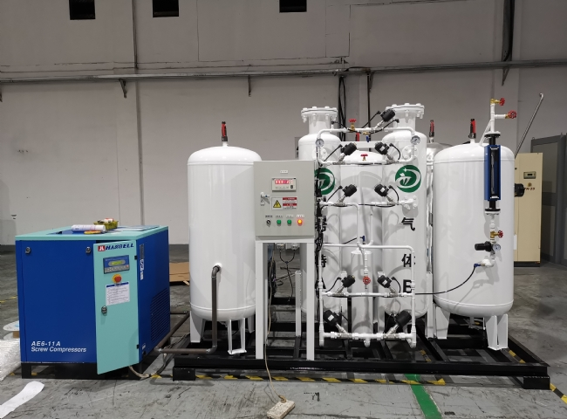
The ability to generate their own nitrogen means that the user has complete control over their nitrogen supply. It offers many optimal configurations for companies that require nitrogen on a regular basis.
With an on-site nitrogen generator， you don't have to rely on third-party delivery， thus avoiding the labor requirements of handling， refilling and replacing cylinders and the delivery costs of these generators.PSA nitrogen generators are one of the most common and trusted methods of on-site nitrogen production.
How PSA Nitrogen Generators Work
Ambient air contains approximately 78% nitrogen. Therefore， with just one tap， you can save 80-90% of your annual nitrogen costs.
The Variable Pressure Adsorption process uses carron molecular sieves (CMS) to extract nitrogen from the air. the PSA process consists of two vessels filled with carbon molecular sieves and activated alumina. Clean compressed air is passed through one vessel and pure nitrogen comes out as the product gas.
The exhaust gas (oxygen) is discharged to the atmosphere. After a short generation period， when the molecular sieve bed is saturated， the process switches the nitrogen production to the other bed by means of an automatic valve， while allowing the saturated bed to be regenerated by depressurization and purging to atmospheric pressure.
Thus， the 2 vessels are constantly alternating cycles of nitrogen production and regeneration， ensuring that high purity nitrogen is continuously available to your process. As this process requires no chemicals， the annual consumption costs are very low. XITEc PSA nitrogen generator equipment is high quality equipment that lasts for over 20 years with minimal maintenance and over 40，000 hours of service.

