Air separation process flow description

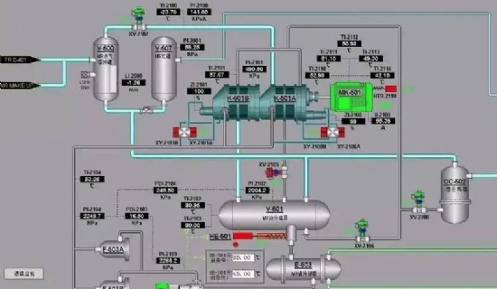
Air separation process flow description
Air separation equipment is a set of air separation equipment with pressurized turbine expander for the adsorption purification of molecular sieve at room temperature and the production of hydrogen-free argon in a conventional packed tower. The process flow is as follows.
4.1 Filtration， compression， pre-cooling and purification
The original process air is drawn in from the suction port， enters the self-cleaning air filter， filters out dust and mechanical impurities， enters the centrifugal air compressor for compression， and the compressed gas enters the air cooling tower in the air pre-cooling system， where it is cooled and water washed. The air cooling tower uses circulating cooling water and low temperature chilled water cooled by a water cooling tower and further cooled by an ice maker. The top of the air cooling tower is equipped with an inertial separator and a screen separator to prevent free water from being carried out in the process air.
The process air from the air pre-cooling system enters the air purification system for adsorption removal of water， carbon dioxide and hydrocarbons. The adsorber in the purification system consists of two vertical vessels， two adsorption vessels with a double adsorption tower structure with activated alumina at the bottom and molecular sieve at the top. When one of them is operating， the other one is regenerated by dirty nitrogen from the cold box heated by a heater.
4.2 Air distillation
Most of the clean process air from the air purification system enters the main heat exchanger in the cold box and is cooled by the gas flowing back out， and the air near the dew point enters the bottom of the lower column for the first fractionation. In the distillation column， the rising gas is in full contact with the downstream liquid and the nitrogen concentration in the rising gas gradually increases through heat and mass transfer. In the main condensing evaporator， nitrogen is condensed and liquid oxygen is vaporized. The liquid air and liquid nitrogen produced in the lower tower are subcooled by the cooler and throttled into the upper tower as the return liquid from the upper tower. In the upper tower， product nitrogen， product oxygen， liquid oxygen and dirty nitrogen are obtained after redistillation.
4.3 Cold production
Most of the cooling required by the plant is provided by the turbo expander.
The rest of the clean air from the air purification system enters a booster driven by the turbo expander to increase its pressure. It is then cooled by a cooler behind the booster and enters the main heat exchanger in the cold box， where it is cooled to a certain temperature and then enters the turbo expander. This expanded air is expanded and cooled in the expander and then enters the upper column to participate in the distillation.
4.4 Argon purification
Argon extraction uses the latest full distillation argon technology， in order to make argon， a stream of argon fraction gas is led from the appropriate position in the lower part of the upper tower of the fractionation tower and sent to the crude argon tower I for distillation to reduce the oxygen content; the reflux of the crude argon tower I is liquid crude argon led from the bottom of the crude argon tower II by a liquid pump. The gas led from the top of crude argon tower I enters crude argon tower II， in which deep argon and oxygen separation is carried out， and after distillation of crude argon tower II， crude argon gas with oxygen content ≤1PPm is obtained at the top of crude argon tower II. The top of the crude argon tower II is equipped with a condensing evaporator， and the liquid air led after the subcooler is fed into it as a cold source after throttling， and most of the crude argon gas is condensed by the condensing evaporator and used as the reflux liquid of the crude argon tower. The rest is led from the top of the crude argon tower (crude argon with oxygen content ≤1PPm) and sent to the fine argon tower， which is equipped with an evaporator at the bottom， using the medium pressure nitrogen at the bottom of the tower as a heat source to evaporate liquid argon， while the nitrogen is liquefied. The top of the fine argon tower is equipped with a condenser， using the liquid nitrogen from the fine argon evaporator as a cold source， so that most of the rising gas condenses as the reflux of the fine argon tower， and after the distillation of the fine argon tower， the fine argon liquid of 99.999% Ar obtained at the bottom of the fine argon tower is led out of the cold box as the product liquid argon.
gas.
4.6 Equipment design and technical features.
4.6.1 Adopt full low-pressure process molecular sieve adsorption， booster turbine expander refrigeration， full distillation of argon， oxygen external compression process. Advanced technology， mature technology， reliable operation， easy to operate， safe and low consumption.
4.6.2 Pre-cooling system uses nitrogen and dirty nitrogen into the water cooling tower to reduce the temperature of the cooling water， air-cooling tower structure using reliable anti-liquid immersion measures.
4.6.3 The channel of main condensing evaporator adopts special structure to prevent acetylene from gathering in liquid oxygen and ensure the safety of main condensing evaporator and system.
4.6.4 The upper tower， crude argon tower and fine argon tower all adopt conventional packed tower.
4.6.5 The equipment has variable working condition operation and equipment variable load capacity， the equipment variable load capacity range is 75% to 105%.
4.6.6 DCS centralized control system is adopted.

