Hydrogen production using the phenomenon of water electrolysis

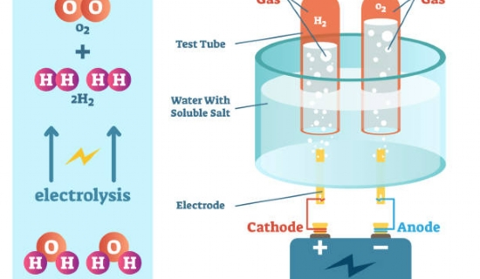
Water is composed of hydrogen and oxygen with the formula H2O. therefore， water can be used as the main source for the production of pure hydrogen. Water electrolysis is the scientific process used by Sooheat for the industrial production of hydrogen. Water is injected into the electrolysis chamber and gaseous hydrogen and oxygen are produced， catalyzed by the current passing through the water. Bipolar high voltage technology is used to carry out this scientific procedure.
Advantages of the water electrolysis process.
Higher quantities of hydrogen
XITE produces individual electrolyzers with a capacity of 0.25 m3/h to 500 m3/h. Therefore， the user can choose the equipment according to his requirements. If someone needs more hydrogen production， they can use multiple electrolyzers connected by a common subsystem.
Useful by-products -
Pure oxygen can also be produced by water electrolysis， although in much smaller quantities compared to hydrogen. A membrane called a proton exchange membrane (PEM) separates the cathode from the anode to prevent the mixing of hydrogen and oxygen.
Low-cost source -
In this process， deionized water is used to produce pure oxygen on the anode side of the electrolysis chamber. Direct current is required to pass this water for electrolysis， which is also easily available at a low cost. Thus， this procedure is an affordable method of producing hydrogen for mass production for industrial use.

