Installation of 15m3/h nitrogen generator equipment for snack food packaging in eastern China

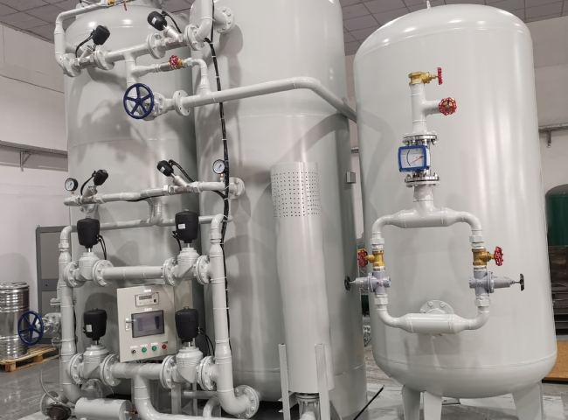
XITE installed another PSA nitrogen generator unit for our customer in Eastern China for use in the food packaging industry.
Customers in the food packaging industry are increasingly aware of the benefits of using nitrogen fill to package their food products such as snacks， cheeses， crush-proof snacks and many others.
Nitrogen keeps food fresh because it avoids the presence of oxygen， which inhibits the growth of bacteria， mold， etc.， that would otherwise damage the food. The nitrogen produced by XITE's nitrogen generators is also very dry. The absence of moisture also keeps the food fresh for a longer period of time.

