The most common piping applications for nitrogen

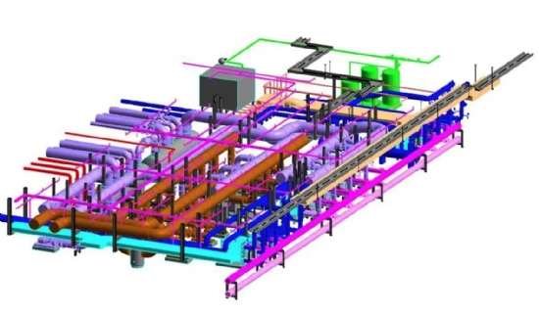
In the past， pipeline construction companies typically built the pipes while pipeline service companies provided cleaning， testing， dewatering， drying， inspection and coating services. Now， these services are provided by the service company or the construction company itself.
These services require high flow rates of air， which can be low or high pressure depending on the application and elevation of the pipeline. The larger the diameter of the pipeline， the greater the demand.
Pipeline projects can have long sales cycles and can be delayed or even cancelled due to permitting， weather or construction delays. Without explaining the pipeline construction cycle in detail， we'll jump straight to the 3 most common applications that typically occur during pre-commissioning， inspection and maintenance.
Pipeline Clearance Work
Dewatering
This process involves removing large amounts of water from the pipeline.
Typically， pigs are fed into the pipeline and driven by air to push the water out. A high pressure compressor， booster and related equipment are required.
The professional dewatering rate is determined by the customer， who in many cases collects the water for environmental reasons.
Drying
Typically， water remains in the pipe after it has been dewatered.
Drying air enters the pipe under pressure and absorbs the remaining water in the pipe.
Compressors and dryers with pressure dew points as low as -40 degrees Fahrenheit or lower are typically provided to ensure the shortest possible drying time.
Blowdown and inerting
These procedures are typically performed in new natural gas pipelines. Nitrogen is injected into the pipeline and then the air in the pipeline is safely purged.
These procedures are essential. They not only replace oxygen， but also delay oxidation and avoid explosions by not allowing air and natural gas to mix in dangerous concentrations.
Nitrogen generators with different flow rates and purity are matched with compressors and booster to achieve the desired nitrogen pressure and flow rate.

