How do rotary screw air compressors work?

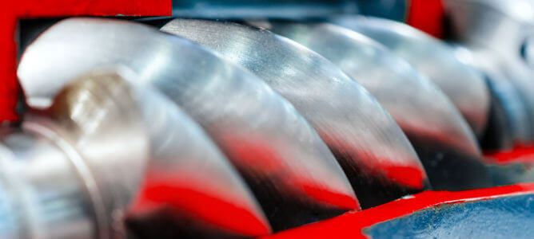
Air compressors are a common piece of equipment in industrial facilities. The reason is simple: pressurised air is required to carry out most industrial processes. This article explores how rotary screw compressors work， as well as the various types， benefits and applications.
What is a rotary screw air compressor?
A rotary screw air compressor uses a rotary positive displacement mechanism consisting of a helical gear (screw) to compress air by reducing the volume of the chamber. It operates somewhat like other compressor types， such as reciprocating piston and centrifugal compressors.
The main difference between rotary screw air compressors and reciprocating and centrifugal air compressors is that they provide a constant (non-pulsating) flow of compressed air and are 100% duty cycle machines.
Single screw and twin screw compressors
Rotary screw compressors can be divided into two categories according to their design: single screw and twin screw.
Single-screw air compressors (also known as ported compressors) consist of a single main screw that engages with two paired gate rotors within a metal housing.
Twin-screw compressors contain two helical screws (one called the 'male' and the other the 'female') that engage with each other to compress the air.
A single-screw compressor is usually less expensive to manufacture than a twin-screw compressor and is easier to maintain. It also offers better performance and efficiency in a smaller size. However， a twin-screw compressor is more efficient in larger sizes， it can handle higher pressure ratios and it can operate at higher temperatures than a single-screw compressor.
Oil-free versus oil-injected compressors
To further classify screw air compressors， there are oil-free and oil-injected versions. Let's take a closer look at these variants below.
Oil-injected (also known as oil-immersed) screw compressors contain a lubricant (oil) in the compression chamber which reduces friction between the moving parts. However， oil does not only provide lubrication; it also acts as a coolant， reduces the temperature of the compressed air in the compression chamber and prevents leaks by acting as a hydraulic seal. Oil-free compressors do not contain oil in the compression chamber. Instead， they rotate using a set of timing gears in which the mating screws do not come into direct contact with each other.
Oil-impregnated compressors achieve a higher PSIG than oil-free compressors and run cooler because the air end has oil as a coolant. However， oil encountering treated air can cause contamination， so oil-immersed compressors are not suitable for industrial processes where high purity is required.
Oil-free screw compressors typically have a lower PSIG than oil-injected types， but keep the compressed air free from contamination - a highly desirable quality for food-grade and pharmaceutical applications.
。

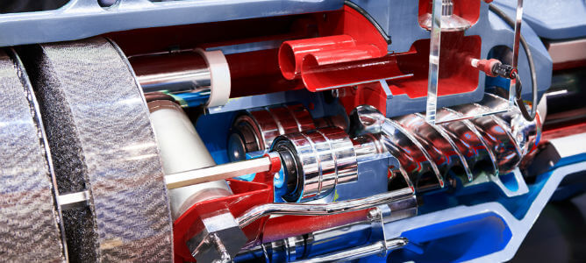
Rotary screw compressors. How it works
So how does a rotary screw air compressor work? A rotary screw compressor works by increasing the pressure of air in an enclosed space as the volume decreases. Uncompressed air is drawn into the compressor through the inlet valve. As it flows through the compression chamber， the positive displacement action of the engaged screw pressurises the air by rapidly reducing its volume. A series of filters separates unwanted moisture and residues from the compressed air outlet.
The main components of industrial screw air compressors
Industrial screw-type air compressors are high-performance， high-efficiency machines for the production of compressed air. They are an important component of many industrial processes. The main components of a screw-type air compressor include the following.
Inlet valve - The suction valve that introduces dry air into the combustion chamber.
Outlet valve - The valve that supplies compressed air to the system or process.
Compression Chamber - Where the compression of air occurs; also called the "air end".
Air Filter - Found in oil-injected compressors， the air filter separates moisture and oil residues from the compressed air， producing dry air at the outlet valve.
Oil Filters - Oil filters purify the oil in the system to prevent the build-up of contaminants and unwanted residues. They also provide lubrication to machine components for smooth operation.
Oil separators - Oil separators help to remove residual oil/grease from the compressed air.
Rotors/rollers - The main compression mechanism consists of a matching screw with multiple lobes.
Bearings - The bearings help to minimise friction between the meshing screws， ensuring longer lasting operation and higher efficiency.
Applications of Rotary Screw Compressors
Rotary screw compressors are most often used for industrial applications such as refrigeration and air conditioning， or for material handling in large manufacturing plants. They can also be found in small-scale applications such as portable air compressors or vacuum cleaners.
Many industries require a reliable flow of compressed air for their operations， which makes rotary screw air compressors ideal. Here are some of the industries that use them.
Oil and gas
In the oil and gas industry， rotary screw air compressors are used for gas lifting (secondary recovery)， where high pressure gas is injected into the surrounding formation to increase hydrocarbon production. Other applications include pipeline maintenance services， equipment cleaning and gas pipe-filling.
Manufacturing
In manufacturing facilities such as automotive assembly， pharmaceutical and chemical equipment， operators use screw-type air compressors to operate compression-powered tools such as pneumatic drills and hydraulic tools. Other applications include equipment cleaning and general maintenance.
Food packaging
In food manufacturing plants， screw-type compressors provide compressed air to operate blow moulding machines for food packaging. They are also used for gas flushing food packaging， product sorting and shaping. Oil-free screw-type air compressors are more suitable for food-grade applications.
Construction industry
In the construction industry， rotary screw compressors provide high pressure air to operate heavy tools such as jacks， pneumatic tools and sandblasters. Compressed air is also required for mud blowing， slurry blowing/hole washing and construction piling operations.
Agriculture
Heavy agricultural equipment， such as tractors， pumps， sprayers and crop conveyors， can be driven by rotary air compressors. In addition to conventional farms， they are also used on dairy farms and greenhouses.
Energy
Oil drilling on oil rigs finds rotary air compressors particularly useful. Reliable equipment is necessary for these operations in order to ensure the safety and protection of the personnel. Their spark-free delivery and constant output are ideal in delicate and isolated processes such as oil drilling platforms.
The benefits of rotary screw compressors
Rotary screw air compressors are one of the most energy-efficient types of air compressor. They are also more compact， which makes them ideal for smaller spaces. Rotary screw air compressors offer the following benefits to industrial operators.
Continuous operation (full duty cycle)
Easy maintenance
Quieter operation compared to other compressor types
Contributes to energy savings
Can operate over most temperature ranges
Safe and easy to use
All these benefits of rotary air compressors make them a popular choice for many different industries.

