Process flow and development advantages of PSA nitrogen production equipment

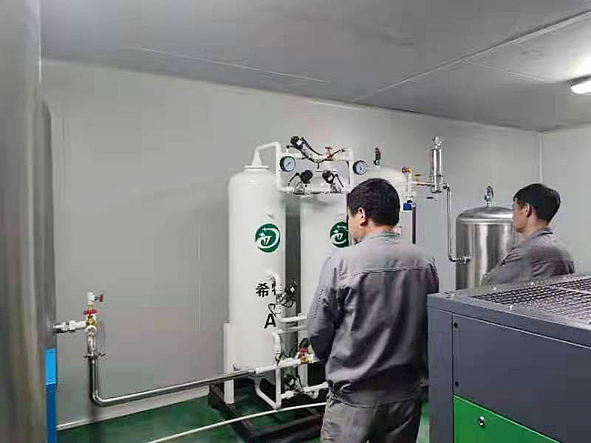
Process introduction
The energy consumption of PSA nitrogen production equipment is mainly concentrated in air compressor and cold dryer. The air compressor provides compressed air with a certain pressure to provide raw materials for nitrogen generator equipment; The cold dryer freezes the compressed air to remove the moisture in the compressed air， so as to reduce the load of molecular sieve in the nitrogen generator equipment. The energy consumption of both depends on the energy consumption of their own equipment and the gas consumption required by nitrogen generator equipment. The former can be solved by selecting air compressor and cold dryer with low energy consumption， while the latter can be solved only by improving the process and related technology of nitrogen generator equipment， which is the key to improve the recovery rate of molecular sieve and reduce the energy consumption of nitrogen production.
In addition to the inlet， outlet and exhaust pneumatic valves， the traditional pressure swing adsorption nitrogen production equipment also has a pair of upper pressure equalizing and lower pressure equalizing pneumatic valves. When the nitrogen generator equipment is in the pressure equalizing state， the gas is separately injected into the inlet and outlet ends of the adsorption tower just after desorption from the inlet and outlet ends of the adsorption tower just after work. The purpose of pressure equalization: first， make the pressure of the two towers consistent and reduce the impact of molecular sieve in the adsorption tower during switching; Second， a part of nitrogen rich gas is transferred from the adsorption tower at the end of work to the adsorption tower at the end of desorption， which reduces the amount of evacuated gas and improves the nitrogen recovery rate.
After pressure equalizing， the purity of nitrogen in the two towers is generally the same， so it is also called equipotential pressure equalizing.
If the lower pressure equalizing outlet position is moved up， the nitrogen purity at the lower pressure equalizing inlet can be improved. During pressure equalizing， the gas with higher nitrogen purity is transferred from the adsorption tower to the desorption tower. The result of pressure equalizing is that the gas purity of the two towers is inconsistent. The nitrogen purity in the desorption tower is higher than that of the adsorption tower. The desorption tower enters the working state and the adsorption tower enters the desorption state. In this way， the nitrogen recovery rate is improved and the nitrogen content of the discharged gas is reduced. This pressure equalization process is called unequal potential pressure equalization or gradient pressure equalization.
2. Test results
The special carbon molecular sieves produced by two domestic manufacturers and Japan are used for comparative test. The test results are shown in Table 1.
The nitrogen production capacity and recovery rate of molecular sieve under different adsorption pressures were investigated with new and old process nitrogen generator equipment. The test results are shown in Figure 1.
Change the adsorption cycle and investigate the nitrogen recovery rate and outlet nitrogen purity. The test results are shown in Figure 2.
3. Analysis of test results
(1) It can be seen from table 1 that the nitrogen production rate and recovery rate of ritianzhi zeolite are better than domestic molecular sieve， and domestic A is better than domestic B.
(2) It can be seen from Figure 1 that the recovery rate of the new process is higher than that of the old process， and the higher the purity of nitrogen， the greater the difference. When the purity of nitrogen is not more than 99%， the recovery rate of the new process is 10% higher than that of the old process; When the purity of nitrogen is 99.9%， the recovery rate of the new process is 29% higher than that of the old process; When the purity of nitrogen is 99.99%， the recovery rate of the new process is 73% higher than that of the old process; When the purity of nitrogen is 99.999%， the recovery rate of the new process is 157% higher than that of the old process; When the purity of nitrogen is 99.995%， the recovery rate of the old process has no practical significance. The variation law of nitrogen production rate of molecular sieve is also similar to that of recovery rate.
(3) As can be seen from Fig. 2， the purity of outlet nitrogen increases with the increase of adsorption cycle， and begins to decrease slowly after reaching the peak; The nitrogen recovery rate increases with the extension of adsorption cycle. In order to take into account the purity and recovery of nitrogen， an adsorption cycle range was determined.
3. Characteristics
Compared with the traditional special carbon molecular sieve nitrogen generator， this product has the following characteristics:
(1) High nitrogen recovery rate and low unit energy consumption. Taking 99.9% as an example， the energy consumption per unit of nitrogen under standard state is 0.3kw H / m3， 18% lower than the old products.
(2) From common nitrogen to high-purity nitrogen， 99.995% high-purity nitrogen can be directly produced without purification， which solves the problem that users have no hydrogen source or use gas for hydrogen indicators.
(3) The gas supply is constant and reliable， and the equipment has a high degree of automation. It has the functions of intelligent care and remote control， and the equipment can be used for a long time.
4. Conclusion
(1) Because the nitrogen production rate and recovery rate of Japanese special carbon molecular sieve are better than those of domestic special carbon molecular sieve， all energy-saving special carbon molecular sieves are made in Japan.
(2) The energy-saving special carbon molecular sieve nitrogen generator adopts the unequal potential pressure equalization process， which significantly improves the nitrogen production capacity and recovery rate of the special carbon molecular sieve， reduces the energy consumption of nitrogen production， and can directly obtain 99.995% high-purity nitrogen， which fills the gap in China.
(3) Increasing the adsorption pressure is conducive to improve the nitrogen production capacity of energy-saving special carbon molecular sieve， and the recovery remains unchanged.

