Covering of oil and chemical tanks with a 775m3/h 99.5% purity nitrogen generator

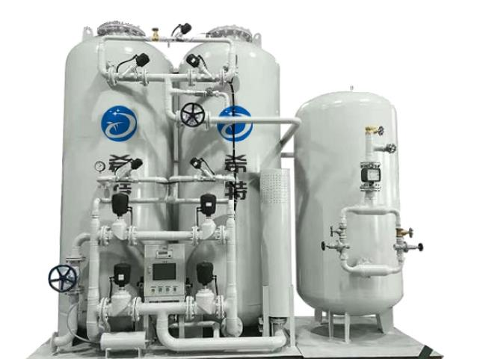
XITE has successfully commissioned 5 PSA nitrogen generators for a multinational conglomerate. The group is a specialist port developer and 5 of our high capacity nitrogen generators are in operation to provide nitrogen coverage for tanks and gas tanks.
The customer purchased the following specifications of PSA nitrogen equipment from XITE
Technology: PSA technology
Capacity: 775 m3/h
Purity: 99.5%.
Application. Oil and gas storage tank cover
Processes
In refineries and chemical facilities， explosive hazards can occur if air enters tanks containing volatile and flammable liquids during pumping. A vacuum is created when the liquid is removed from the tank or when the ambient temperature drops.
In order to professionally protect the tank， its contents and the environment， a low positive constant N2 gas pressure is maintained in the vapor space of the tank. Nitrogen is the most commonly used gas to reduce the oxygen content of the vapor space， making it inert and eliminating the possibility of fire/explosion.
This prevents air and moisture from entering the storage tank. A vacuum may be created when the liquid is removed from the tank or when the ambient temperature drops. The blanketing system prevents any vacuum from being created and maintains the required blanketing pressure. In addition to this， blanket gas pressure， reduces evaporation of stored product to a negligible amount. The result is not only product savings， but also a significant reduction in emissions. The quality of the chemical， which is affected by exposure to moisture or oxygen， can be protected by the nitrogen cover. In addition to these advantages， the use of nitrogen provides fire protection.
Oil and Gas Capping
Tank filling， also known as oil tank filling， is the process of applying nitrogen to the voids of storage containers. Although tank covering is used for a variety of reasons， it typically involves the use of nitrogen to protect the product inside the storage container.

