What is servo motor and what is the difference between ordinary three-phase asynchronous motor

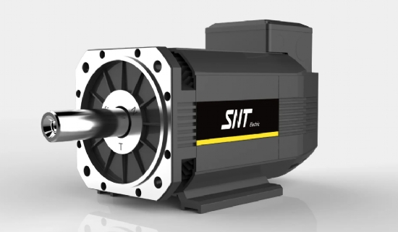
Definition - An engine that controls the operation of mechanical elements in a servo system. It is a kind of subsidized motor indirect variable speed device.
Function - Servo motor， which can make the control speed and position accuracy very accurate. The voltage signal is converted into torque and speed to drive the control object.
Classification - divided into DC servo motor and AC servo motor.
DC servo motors are divided into brushed and brushless motors. Brush motor has low cost， simple structure， high starting torque， wide speed range， easy control， requires maintenance， but easy maintenance (change carbon brushes)， generates electromagnetic interference， and has environmental requirements. Therefore it can be used in cost-sensitive general industrial and civil applications.
Brushless motor is small in size， light in weight， large output， fast response， high speed， small inertia， smooth rotation and stable torque. The control is complex， easy to realize intelligent， and its electronic phase change is flexible， can be square wave phase change or sine wave phase change. The motor is maintenance-free， with high efficiency， low operating temperature， low electromagnetic radiation， long life， and can be used in various environments.
AC servo motor is also brushless motor， divided into synchronous and asynchronous motor， at present， synchronous motor is generally used in motion control， which has a large power range and can do a lot of power. Large inertia， low maximum rotation speed， and rapidly decreases as the power increases. Thus it is suitable for low speed and smooth running applications.
The rotor inside the servo motor is a permanent magnet. The U/V/W three-phase electric power controlled by the driver forms an electromagnetic field， and the rotor rotates under the action of this field， while the motor comes with an encoder feedback signal to the driver， and the driver compares the feedback value with the target value to adjust the rotor rotation angle. The accuracy of the servo motor is determined by the accuracy (number of lines) of the encoder.
In terms of function， AC servo is better because it is sine wave control with small torque pulsation; DC servo is trapezoidal wave. But DC servo is simpler and cheaper.

