Nitrogen generator for coal mine

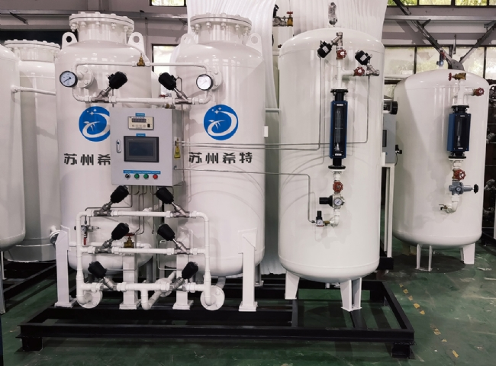
Safety regulations for inert gas in coal mines using nitrogen generator systems
The primary application of nitrogen in the mining industry is to extinguish coal mine fires. However， the latest regulations require miners to inert waste/working areas in mines where the installed containment is inadequate.
The key initiative to extinguish coal mine fires is to reduce the oxygen content of combustible gases to below the lower explosive limit (LEL). Specialty foams are sometimes injected with nitrogen to help seal air into the fire and to help cool the surface of the coal embers once the LEL is reached. Continuous injection is required for several days， and in some cases months. Pulling nitrogen to the mining site or using nitrogen is costly and creates safety issues. A more reliable and cost effective method is to generate nitrogen on site by utilizing a powerful Gaztron nitrogen system.
Features and benefits of using nitrogen.
- Engineered N2 gas generation solutions that meet any purity specification
- Engineered N2 generators to meet required flow rates
- XITE generators can be easily transported to the site and are simple to install
- Eliminates ongoing costs associated with N2 supply
- Suitable for direct injection or as a carrier gas for foam to maintain an inert atmosphere
- Project engineering and design support provided by Schitt
- 24-hour post-installation service and support
Gaztron Engineering Pvt Ltd nitrogen generators are suitable for high pressures and are available in the following models
Equipment capacity range - 5 to 1000 Nm3/Hr.
Nitrogen purity - up to 99.9998%.
Equilibrium oxygen content - 5 to 0.5%.
Dew point range - 20 to -40 degrees C
Discharge pressure - 5 to 25 kg/cm2

