Nitrogen and MAP for food packaging

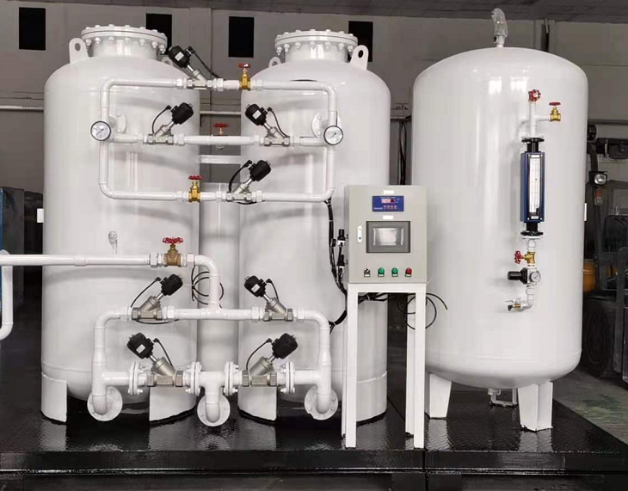
Ever wondered what makes your coffee so fresh and aromatic?
Why do crisps look as fresh as if they had just come out of the packaging?
The answer to most things related to the freshness of packaged food is the almost inert gas nitrogen. We prefer to call it a saint， because it does so much more good than bad. Its large presence and its quality make it a favourite in many food industries. Modified Atmosphere Packaging (MAP) is a common solution in food industry production that helps prevent food spoilage. Oxygen is ubiquitous and， in contrast to nitrogen， it is reactive. Therefore， if it is present in high proportions in food packaging， it can support bacterial growth. This will lead to spoilage of the food in the packaging. In contrast， nitrogen does not support bacterial growth and provides a longer shelf life for the food in the package.
There are a number of foods that derive real benefits from MAP. Please list some of them.
Coffee
Rice
Pasta and noodles
Rice
Biscuits
Packed sandwiches and many more foods
The reason we should use nitrogen for MAP is because of its properties. It is colourless and odourless. It is inert and does not add any kind of flavour to the product. Nitrogen is a dry gas. Therefore， because of all these golden properties it possesses， we prefer to use nitrogen instead of any other gas.
Nitrogen for MAP can be supplied to various industries in cylinders or in bulk liquid nitrogen. However， we recommend that it is best to have a nitrogen production plant on site to avoid the need to transport nitrogen cylinders. Remember， this is a cost effective method and it is also hassle free. Industry owners interested in MAP for food packaging should also be aware that， in addition to being cost friendly， it adds convenience. When you find that you have invested heavily in the installation of a PSA nitrogen plant， rest assured that your investment will pay off.

