Industries benefiting from on-site nitrogen generators

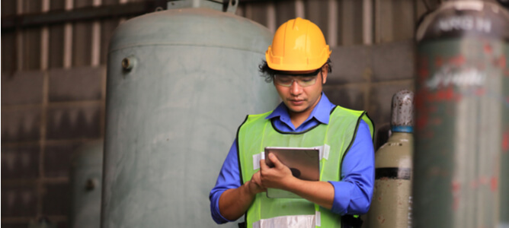
Gaseous nitrogen is very useful in large-scale manufacturing and industrial applications. The large quantities of nitrogen required for these operations are either sourced from suppliers' cylinders or generated on site. In this article we will highlight the key industrial processes that benefit from on-site nitrogen generation systems.
Nitrogen generators by industry， application and type
The market for bulk nitrogen is expanding as more and more industries incorporate nitrogen into their production processes. On-site nitrogen generation systems have proven to be the most economical and efficient way of obtaining the required quantities of gas in a number of applications. There are three main types of nitrogen generation systems.
Pressure-swing adsorption generators
Membrane nitrogen generators
Staged distillation

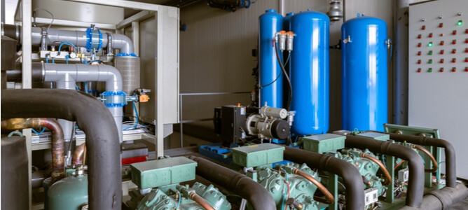
Depending on the unique operational requirements， the configuration and capacity of the nitrogen generator used will vary from process to process. Some key determinants include
The size of the industrial production unit
Minimum acceptable gas purity levels
Available industrial floor space
Some of the key applications for nitrogen generators in various industries are outlined below.
Food and beverage
A major challenge for commercial food manufacturers is to extend the shelf life of their products. Food-grade nitrogen can replace oxygen in the packaging， slowing down the oxidation process that leads to rapid food spoilage and thus increasing shelf life. This food processing technology is known as modified atmosphere packaging and can be achieved by integrating on-site nitrogen production systems into the food manufacturing process.
In addition， on-site nitrogen production in breweries can deliver gaseous nitrogen to the industrial vats used to make alcoholic beverages.
Chemicals and plastics
Nitrogen forms an important substrate in a number of chemical manufacturing processes. For example， nitrogen is used to synthesise ammonia， which is a feedstock for a number of valuable compounds such as nitric acid， fertilisers， dyes and synthetic fabrics such as nylon.
In industries producing synthetic polymers and plastics， nitrogen is applied to rubber and other plastics to harden them. As a result， plastics manufacturers can create materials with higher tensile strength and improved durability.
The above industries often require large quantities of nitrogen， which can be easily supplied using on-site nitrogen generators.
Automobiles and aircraft
Tyres inflated with nitrogen have a number of advantages over pneumatic tyres. Aircraft and racing car tyres are often inflated with nitrogen， which significantly increases the safety rating of the tyre. Other key benefits of nitrogen-inflated tyres include
Slower rate of tyre pressure loss
Improved handling， as tyres warm up more slowly and are less likely to lose grip on the road
Nitrogen-inflated tyres run cooler than air-inflated tyres
Less likely to contain impurities that can damage the vehicle's wheels and distort tyre pressures
Safer to handle temperature fluctuations， resulting in fewer blow-outs and rapid pressure changes

Pharmaceutics
Nitrogen is almost indispensable in the manufacture of synthetic drugs. The pharmaceutical industry benefits from nitrogen generators， which provide useful quantities of the gas as a substrate for the synthesis of life-saving antibiotics and anaesthetics.
Oil and gas
Techniques to improve oil recovery include the injection of pressurised nitrogen into oil-bearing geological formations to improve the declining productivity of wells as they age. Nitrogen can also be used in the drying and dewatering of pipelines， as well as in the pre-commissioning and decommissioning processes of pipelines.
Electronics
Electronic circuit components are often joined together by soldering. Nitrogen soldering is a very popular technique in the electronics manufacturing industry as it produces a clean， high quality finish. In addition， gaseous nitrogen is used in computer processors to prevent thermal damage by cooling delicate components.
Laser cutting
Nitrogen lasers are another application that demonstrates the use of on-site nitrogen generators. Nitrogen lasers enable clean cuts to be made in metal without generating additional heat that could damage the edges of the metal being cut.
Mining
Mining is an industrial endeavour associated with many occupational health risks， not to mention the danger of spontaneous explosions and fires caused by volatile compounds that accumulate in the mining space. Nitrogen is a highly inert chemical that can mitigate the risk of spontaneous combustion by displacing pockets of highly flammable gases.

