The Utility of Nitrogen in Food Aerated Packaging

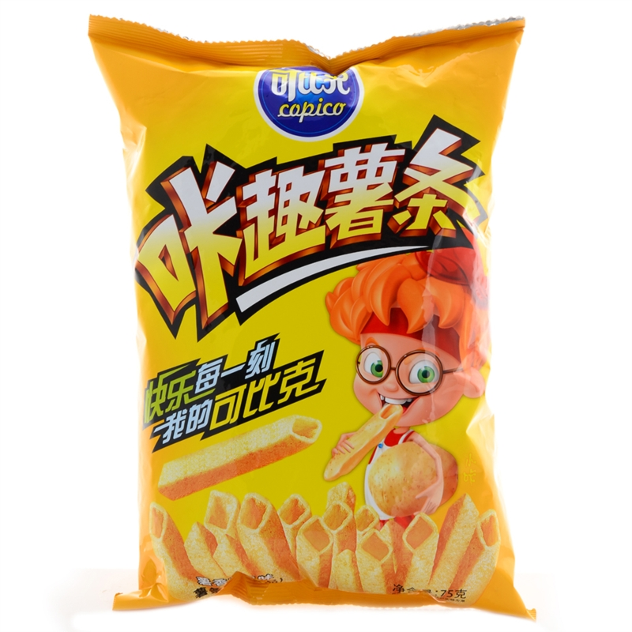
Among the causes of food spoilage， the role of microorganisms is often the most important. Food itself is a good culture medium for microorganisms， if the food is exposed to the air stored at room temperature， it provides good conditions for the growth and reproduction of microorganisms， especially meat， fish， eggs and vegetables and other water-containing， nutrient-rich animal or plant foods， microorganisms in which they can grow and reproduce rapidly， promote the rapid decomposition of food nutrients， so that it is decomposed from polymer materials into low molecular matter， resulting in the deterioration of food quality and ultimately spoilage and corruption. This will lead to the deterioration of food quality and eventually spoilage and corruption. Microorganisms that can cause food spoilage and corruption include bacteria， yeasts and moulds. Among them， the deterioration caused by the action of bacteria is the most significant.
The deterioration of food also lies in the action of enzymes. Enzymes are biological catalysts that induce chemical changes without consuming themselves. Both animal and plant foods contain enzymes. Under the catalytic effect of enzymes， biochemical reactions occur， causing food spoilage. The increase of spoilage products， such as amino acids， creates favourable conditions for the reproduction of spoilage microorganisms and accelerates the deterioration and corruption of food. Moreover， in the process of microbial life， it will produce a variety of enzymes. It can be seen that microorganisms and enzymes promote the deterioration and corruption of food.
Some of the chemical reactions that cause food spoilage are not directly related to enzymes. Such as food stored in the air， the oils and fats contained in direct contact with the oxygen in the air oxidation reaction occurs， the generation of ketones， aldehydes， acids， ethers， lactones and other organic substances， while the viscosity and specific gravity of the fat itself increases， resulting in an unpleasant ha ha odour， known as oxidative rancidity of fats and oils， commonly referred to as the oil ha.
The presence of peroxides in fats promotes the acceleration of rancidity， which leads to the deterioration of food and the loss of its commercial value. In addition to fats and oils， vitamin C in foods is easily oxidised into dehydrovitamins in air. Dehydrovitamin C can continue to decompose， and finally produce diketogulose acid， then lose the physiological efficacy of vitamin C.
Foods exposed to the air， under the action of oxygen， there will also be changes in colour. Such as raw meat in the air after a period of time， its colour will change from purple red to bright red， and then to brown. This colour change， is the animal muscle tissue pigment myoglobin， by the air in different ways and degrees of oxygen caused by the action. Again， such as tomato pigment， by the eight isoprene platform， the structure has more conjugated double bonds， easy to be oxidised by oxygen in the air. Others， such as carrot pigments， are also susceptible to oxidation. Oxidative changes in food colour will naturally reduce the original quality of food.
In summary， food deterioration and corruption caused by the phenomenon， almost all directly or indirectly with the presence of oxygen in the air， that is to say， the presence of oxygen， is caused by food deterioration of an important external factors， the storage of food plays a harmful role.
Therefore， in order to prolong the custody and storage period of food， how to find ways to artificially isolate food from oxygen in the air， do not allow it to contact with oxygen， to prevent the oxidation of fat and other microbial reproduction， when it is one of the research topics of food preservation technology. At the same time， make the food and air isolation， but also can effectively prevent the food in the water from its surface evaporation or sublimation to the air， that is， to overcome the phenomenon of dry consumption. Dry depletion will not only reduce the weight of the food， but also inevitably accompanied by a decline in quality， such as reduced flavour， surface shrinkage， colour change， and promote oxidation， thereby accelerating the deterioration of food. Therefore， to prevent and reduce the occurrence of food in the preservation of the phenomenon of thousands of consumption， but also to avoid the rapid deterioration of food， to maintain its inherent commodity value of an effective way.
Shrink packaging of food， vacuum packaging， inflatable packaging and other forms of packaging principles， is based on trying to make food does not come into direct contact with the air， and oxygen isolation up and can effectively prevent the oxidation of food fats and other nutrients and microbial growth and reproduction， so as to achieve the purpose of prolonging the preservation of food. The so-called shrink packaging， is the packaging， pumping， sealing after the food bag immersed in hot water or hot air， steep film due to heat contraction and tightening to tightly wrap the food. This method of packaging is simple， low cost， smooth products， with the table， not easy to puncture， good shelf life. The so-called vacuum packaging， is the bag of air pumped out， a vacuum state. Bag due to less oxygen， inhibit the propagation of bacteria， to extend the shelf life， and can pack large pieces of food. In recent years， the research， development and popularity of inflatable packaging， the order of operation is to fill the food into the airtight film bag， seal the mouth， exhaust the air inside the bag， and then filled with eight "inert" gas， so that the food and the oxygen in the air to isolate the food， thus preventing oxidation and deterioration of food and microbial reproduction. The effect of inflatable packaging than shrink-wrapping and vacuum packaging are superior， is a more ideal new packaging method.
Inflatable bags filled with gas， generally speaking， can be nitrogen， can be carbon dioxide， can also be a mixture of N2 and CO2 gas. But whether it is filled with N2， CO2， or their mixed table gas， the oxygen content of the bag should be controlled below 0.5%. N2 filling CO2 filling and filling N2 and CO2 gas mixture and other three kinds of inflatable situation， in order to fill the N2 the best results. This is because carbon dioxide is an acidic oxide that can combine with water in food to form carbonic acid. Although carbonic acid is a weak acid that can inhibit the reproduction of bacteria， since it is an acid that is not inert or neutral but weakly acidic， it may affect the colour and other aspects of foods such as meat. Nitrogen is completely inert to foodstuffs， and it has no effect on the colour， aroma， taste and other aspects of foodstuffs.
Colour， aroma， smell and other qualities of food will not cause any effect， but can well prevent the proliferation of bacteria， yeasts and moulds， etc.， to prevent such microorganisms on the harmful effects of food may be caused by the corruption of deterioration， but also very effective in preventing the rancidity of the food in the oil and grease， the oxidation and decomposition of vitamin C， as well as oxidation of the original colour and lustre of the original change， and greatly prolong the perishable foods of all kinds of storage and safekeeping Period， iterative to the effect of freshness. Such as nitrogen-filled packaging of pork， stored at an ambient temperature of 3 to 7 ℃， after ten days of storage is still very fresh， there is no odour and other odours， the colour is almost unchanged， and there is no bacteria on the surface， moulds or trichoderma breeding colonies， and there is no viscous phenomenon on the surface of the meat.
Sausage and other meat products for the nitrogen packaging test， usually at room temperature can be stored for several months， no mould， but also did not produce the unpleasant "what la" taste. Moreover， due to the airtight packaging， the phenomenon of thousand consumption is avoided， so that its weight is not reduced in the slightest.
Inflatable packaging， especially nitrogen-filled packaging， the total energy consumption than freezing or canning nearly halved， and the operation is relatively simple and convenient， in the transport， storage and sales and other commercial circulation links do not need refrigeration. Inflatable packaging of general meat， water and vegetables and other foods， at room temperature can be stored for 1 to 8 months Li does not deteriorate， does not reduce its due commodity value. Therefore， inflatable packaging， especially chlorine-filled packaging， it is as a low temperature technology in the food industry， due to nitrogen resources， easy to obtain， safe and reliable performance， inexpensive， so with its unique vitality， new means of food preservation technology research and application， more and more attracted the attention of domestic and foreign people.

