Use of nitrogen machines to produce cleaning gas

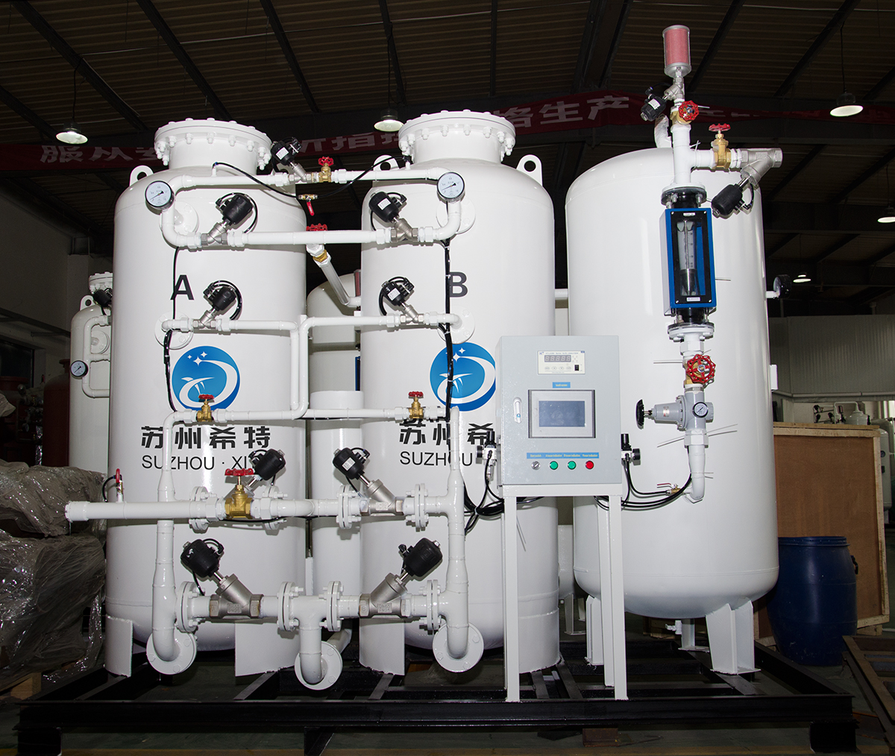

Nitrogen plants are used for the consistent generation of nitrogen on demand. They provide a convenient， safe and cost-effective source of nitrogen with a faster return on investment. Did you know that these nitrogen generators can also be used for scavenging gases? Here's how.
Using nitrogen generators to create scavenging gas
With the help of a membrane contractor or simply a contractor， the liquid and gaseous phases come into direct contact. This allows a large transfer between the two phases without causing scattering of the two phases. The main purpose of this device is to remove the oxygen from the water stream by operating the membrane contractor， placing the liquid water on one side of the hydrophobic membrane and applying a vacuum and nitrogen sweep on the other side of the membrane. The membrane will now allow the liquid water to enter the gas side of the membrane through the pores as it is hydrophobic.
Oxygen can be removed from the water side of the contractor by varying the finite pressure of the nitrogen. This task is accomplished with the help of the breakthrough pressure equation. When using lower pressures and nitrogen as the sweep gas in a vacuum， the oxygen in the water stream migrates through the hollow fibres as it is attracted to the low pressure side of the contractor. Here we also mention that the quality of the sweep gas together with the breakthrough pressure is also very important for the process.
Purity levels
Depending on the final process using degas water， different grades of nitrogen purity are available as sweep gas. According to industry standards， most sweep nitrogen applications have a purity level of 99.99% or higher. This level of purity is also recommended and necessary.
Manufacturers of nitrogen programmes now offer a nitrogen generator which can conveniently produce nitrogen exactly as required through a simple and safe mechanical air separation process.

