What should I do if I have a high purity nitrogen leak?

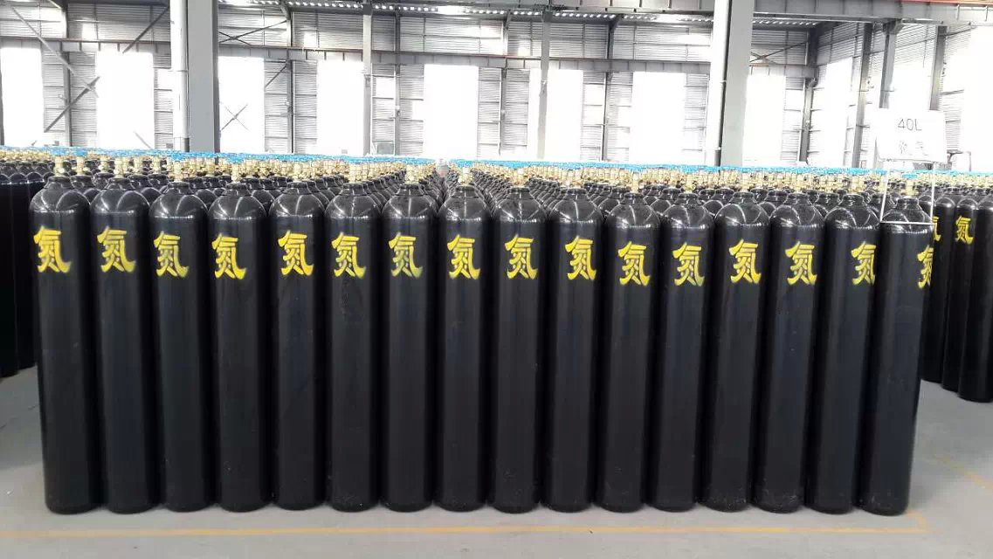
What should we do when high purity nitrogen leaks?
In understanding the solution to liquid nitrogen leakage， let us first understand some of the symptoms of inhalation of nitrogen: inhalation of nitrogen concentration is not too high， the patient initially feel chest tightness， shortness of breath， weakness; followed by irritability， extreme excitement， running around， shouting， trance， unstable gait， known as "nitrogen tincture"， and can be entered into a drowsy or comatose state. Coma. Inhalation of high concentrations， the patient can quickly coma， due to respiratory and cardiac arrest and death. Let's take a look at how to deal with it
1、Evacuate the leaking contaminated area to the upwind place， and set up isolation area， strictly restrict the access.
2， notify the fire and related units.
3、Emergency personnel wear self-contained positive pressure respirator， wear winter clothes and gloves.
4、Avoid leaking liquid into the basement or other confined manned work space， if it can not be avoided should immediately notify the relevant departments.
5， do not directly contact with the leak.
6， cut off the source of leakage as far as possible.
7、Mist water spray can be used to accelerate the evaporation of liquid， but do not make the water gun shot to the liquid.
8、Prevent the gas from accumulating in the low concave place， use exhaust fan to send the leaking gas to the open place.

