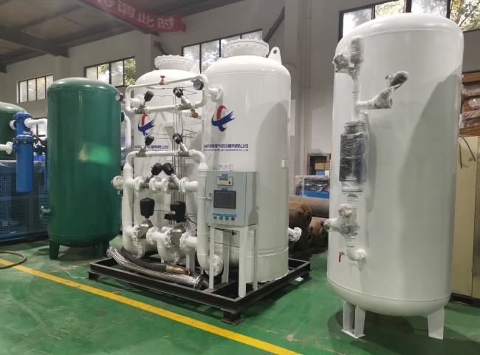
Suzhou XITE has installed a nitrogen generator for die casting with a purity of 99.9%， a working pressure of 5 KG/CM2 and a power of 30 m3/h.
Suzhou XITE is a manufacturer of nitrogen generators for die-casting process. In this process， the machine is built with the best quality of materials and components. The machine can be operated on manual and semi-automatic basis and is best suited for mass production of die-cast parts such as aluminum， zinc and other alloys for casting of automobiles， electrical appliances， toys， measuring instruments and household appliances. Schitt offers a complete range of nitrogen generators for the metal casting industry and other industries such as gas and oil refining. Nitrogen can be used for degassing and cleaning of non-ferrous metals. Degassing of molten aluminum alloys is a casting operation designed to remove the hydrogen dissolved in the melt.
You can now generate your own nitrogen as you need it at a fraction of the cost of your existing supply and with the purity required for your process. Nitrogen generators are virtually maintenance-free. Simply turn on and use the nitrogen.
Model | Capacity m3/h
XTFD-30 | 30 m3/h

