Atmospheric pressure vacuum degassing technology
Today， the secondary metallurgical unit represents a versatile and usable link between the primary steelmaking process and the liquid steel continuous casting process. Vacuum degassing is an important secondary steelmaking process. The process was originally used to remove hydrogen from the steel， but is now also used in secondary refining and has become an increasingly important secondary steelmaking process. Lower hydrogen and nitrogen content， ultra-low carbon content， ultra-low sulfur content， low total oxygen content and cleanliness of the steel are the reasons for installing vacuum treatment facilities in steel melting plants.
In new steel plants， vacuum degassing facilities are considered and integrated into the steel production line. There is also a trend to install vacuum handling facilities in existing plants in order to provide steel mills with the opportunity to expand their product mix and respond more flexibly to the steel market situation.
Since the 1950s， several vacuum technologies have been developed for degassing purposes. These technologies include DH (Dormund Hoerder) degassing， RH (Ruhrstahl Heraeus) degassing， vacuum tank degassing (VTD)， vacuum arc degassing (VAD) and vacuum induction melting (VIM). In the present case， RH degassing and VTD processes are usually used for large-scale production of steel to reduce the gas and carbon content of the melt. the choice of RH degassing or VTD is strictly determined by the steel grade produced by the steel mill. In most cases， the RH degassing installation is more advantageous compared to VTD， especially for large heat mills because of its good mixing properties and short decarbonization and degassing cycle times， resulting in a large number of heat treatments per day. Due to the short cycle time， the RH degassing process can handle a large amount of heating per day. In addition， due to the good mixing performance achieved in the process， short treatment times can be achieved regardless of the ladle size.
The RH degassing technology was first introduced in the late 1950s in Germany， where the first RH degassing plant was developed and installed. the RH degassing process is named after Ruhrstahl and Heraeus， where the process was originally developed. Since then， many process improvements have been made to the RH degassing equipment. These improvements include the installation of oxygen lances， the enlargement of breather tube and vessel diameters， and the application of powder injection for desulfurization. kuwabara presented a comprehensive model for decarbonization of RH degasification equipment， taking into account vacuum pressure， lift gas flow rate， vessel and breather tube diameters. The time required to reach a carbon content below 20 ppm (parts per million) in RH degassing equipment can reportedly be accomplished in less than 15 minutes.
When equipped with an additional top bar， RH degassing is referred to as RH-TOP degassing.RH degassing and RH-TOP degassing equipment (Figure 1) use the vacuum recirculation process principle and are particularly suitable for producing steel grades with very low carbon content under economically favorable conditions.The main functions of RH degassing equipment are hydrogen removal， natural and forced decarburization， chemical heating of the steel， and precise adjustment of the steel chemical analysis and temperature. These activities are carried out under vacuum conditions. Low hydrogen content is the main prerequisite for the production of high-strength steel grades and those used in the oil and gas industry. Relative humidity degassing technology allows to achieve very low hydrogen content in a very short vacuum time.

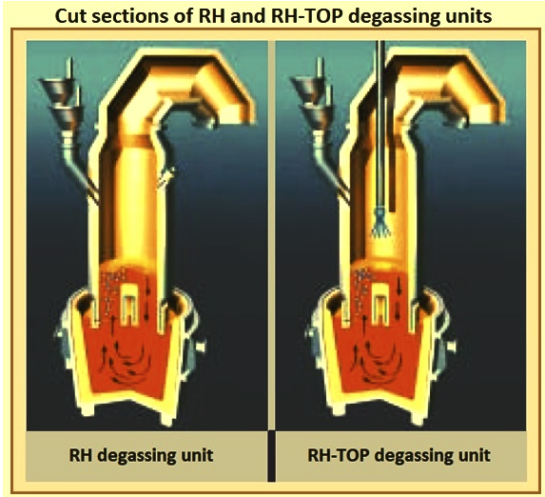
Fig. 1 Cross-sectional view of RH and RH-TOP degassing equipment
As a tool for secondary refining of liquid steel， the RH degassing process has most applications due to its multiple metallurgical functions， such as vacuum degassing， decarburization， inclusions removal， denitration and inclusions removal. It is widely used for the production of ultra low carbon steel， bearing steel， pipe line steel， spring steel and silicon steel.
RH degassing equipment usually consists of a refractory-lined block or split vessel with two refractory-lined breathing holes in the bottom of the vessel connected to a vacuum pump. Other components include a hydraulic or mechanical vessel or ladle lifting system (in the case of RH-TOP)， a multifunctional top blow gun， and a measuring and sampling system. The addition of material under vacuum is accomplished by a vacuum hopper system. Vessel， breather and top refractory maintenance and preheating can be performed in a separate rack. The design features a single vessel installation (vessel lift system)， rapid vessel exchange (ladle lift system) or a duplex vessel installation for increased availability.
The RH cycle degassing process has proven most of its suitability in a large number of steel melting plants worldwide and can be operated in short tap times and cover heat sizes up to 400 tons. The steel produced by the vacuum treatment in the RH degassing plant meets the requirements for high steel quality. To achieve this， the liquid steel is allowed to circulate in the vacuum chamber， where a significant drop in pressure breaks it down into its smallest parts. The increased surface area allows the liquid steel to be degassed to the greatest extent possible. This process requires reliable vacuum equipment capable of sucking out very high flow rates in dusty environments and high temperatures.
The RH degassing process depends on sucking the steel from the ladle into a vacuum chamber equipped with two breathers (upper and lower legs). The circulation of the liquid between the vacuum chamber and the ladle is forced when the inert gas is blown into the liquid. The degassing process takes place mainly inside the liquid， in the vacuum chamber and at the metal splash on the bubble surface， where complex chemical reactions and transport phenomena are involved. Figure 2 shows the principle of the process and the lining of the vessel and other parts of the process.

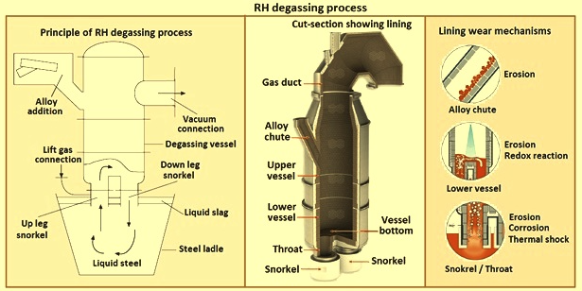
Figure 2 Relative humidity degassing process
Process Development
When the RH process was first introduced， the main objective was to reduce the hydrogen content of the steel. The first results were not as successful as expected due to insufficient vacuum in the vessel.In the early 1960s， the application of steam ejector vacuum pumps allowed to reach pressures low enough to result in hydrogen content below 1 ppm.Since then， the RH degassing process has been continuously developed in terms of vacuum conditions， design and geometry of the reaction vessel (size and shape)， cross section of the breathing tube and capabilities of the RH degassing equipment The RH degassing process has been continuously developed in terms of vacuum conditions， reaction vessel design and geometry (size and shape)， breather tube cross-section and capacity of RH degassing equipment.
The application of the RH degassing process for decarburization first appeared in the late 1970s. Today， the use of this process results in very low final carbon content of less than 20 ppm， which is required for the production of automotive sheet. The advantages of adding alloying elements to the degassing process are that higher yields of ferroalloys can be obtained and the high accuracy of the chemical analysis of the steel due to the absence of air and the avoidance of metal slag reactions.
A further development is the use of gaseous oxygen in the RH degassing process in the RHO， RH-OB， RH-KTB， RH-MESID and MFB processes. In the MFB process， the RH degassing equipment is equipped with a multifunctional burner (MFB). the MFB is a device that enables fuel and oxygen to be blown from a single lance inserted into the vacuum chamber. It allows the heat to be retained in the vacuum chamber both during the vacuum treatment and during standby. This reduces the adhesion of the metal in the vacuum chamber while making it possible to produce ultra low carbon steel by blowing oxygen during the process. The aim of these processes is to accelerate the decarburization reaction， to reheat the steel by an aluminothermic reaction， to remelt the skull， to keep the vessel hot by converting the carbon monoxide gas produced to carbon dioxide gas during decarburization， and to heat the refractory lined vessel between treatments. More recently， a number of RH-TOP lances have been used to blow powder into the steel to reduce the sulfur or carbon content to a minimum level. Today， all of these processes， except RH-OB， are known as RH-TOP degassing processes.
Basically， the development of RH degassing and RH-TOP degassing processes is important to (i) improve decarburization conditions and speed up decarburization and degassing by improving vacuum pumps， breather design， and vessel design; (ii) increase the rate of ferroalloy addition (iii) separating these activities from RH processing by installing dedicated stations for activities such as alloying or wire addition， and (iv) optimizing plant layout to reduce the cycle time impact of ladle transport time and nozzle immersion time.
Relative Humidity Degassing Plant Concept
A unique feature of the RH degassing process is that various plant concepts can be rationally built to suit the specific layout of the steel melting shop， the required cycle time， and to meet availability requirements. A series of design criteria that can be considered for RH degassing plants are given in Table 1.

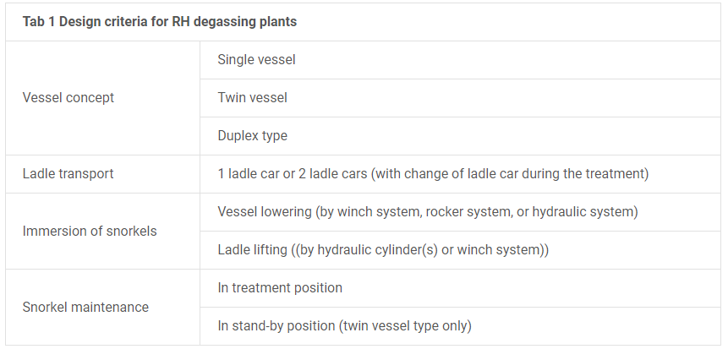
The cycle time， metallurgical capacity and regular high quality production of RH degassing equipment depends on (i) the concept of the RH degassing equipment， (ii) the embedding of the RH degassing equipment in the process flow of the steel melting plant. (iii) the design of the RH vessel， (iv) the performance of the vacuum system and other components of the RH degassing plant， (v) the regular maintenance of the refractory material， (vi) slag conditioning and slag metallurgy， (vii) the overall stable production conditions， and (viii) the automation system. Figure 3 shows the typical basic concept and the main components of a RH degassing plant.

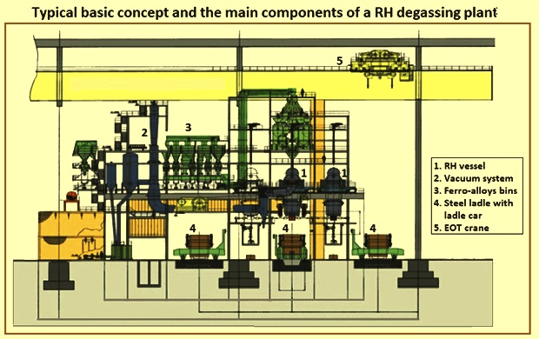
Figure 3 Typical basic concept and main components of a RH degassing plant
Relative humidity degassing equipment is usually equipped with a 2-stage automation system. 2-stage automation system includes hardware， system software and application software， which is implemented on the basis of metallurgical models. 2-stage application software and model software are designed as independently executable programs. The application software provides the model with data from different sources and receives the calculated model data. The communication between the application software and the model software is implemented through database tables， which provide input data to the model and receive the model's output. Level-2， on the other hand， collects all processing data for transmission and thermal report generation. Level-2 automation is primarily operated by a single dialog that is typically designed to accompany process observations and provide setpoint data to be executed on Level-1 automation. Level-2 automation requires only a small amount of operator input.
Characteristics of the RH degassing process
The process consists primarily of a refractory-lined cylindrical reaction vessel with two steel pipes connected at the bottom. The upper part of the reaction vessel is lined with refractory clay/alumina bricks and the lower part is lined with alumina/magnesite bricks. The two steel tubes are the inlet and outlet. The interior of both are completely lined with alumina refractory material， but only the lower exterior is coated with refractory material. The inlet nosepiece is equipped with a number of gas injection tubes which are arranged in one or two layers in the lower part， equally distributed around the circumference. The reaction vessel is designed so that the steel rises through the inlet piping and falls back into the ladle through the outlet piping after degassing. The top of the reaction vessel is equipped with venting equipment， as well as facilities for adding ferroalloys， and observation and control windows.
RH degassing equipment is typically used for vacuum treatment and long sequence decarburization of low carbon steel grades. metallurgical and operational features of the RH degassing process include (i) rapid decarburization to below 20 ppm， (ii) dehydrogenation and denitration， (iii) use of less expensive high carbon ferroalloys， (iv) chemical heating of killed and unkilled heat， (v) improved cleanliness of the steel for non-metallic inclusions， and ( vi) good composition control.
The top blow gun system is mounted above the RH degassing vessel and combines multiple functions. Oxygen blowing rates of 2000 N/h to 4000 N/h and installed burner capacities of 2 MW to 4 MW are typical design features of the process. For process supervision， the lance can be equipped with a TV camera. In addition， the top blow lance can be equipped with a powder blowing function for deep desulfurization of the steel. RH-TOP degassing process functions include: (i) forced decarburization and chemical heating by oxygen blowing; (ii) heating of the refractory of the RH vessel by gas/oxygen combustion; (iii) powder blowing for desulfurization; (iv) rapid skull removal by using oxygen injectors; and (v) advanced ignition by external ignition facilities.
The RH degassing process allows the production of the most economical and even unique quality of high volume steel. Very low carbon and hydrogen contents can be achieved in a short processing time. Only minimal temperature losses. No special de-slagging measures， ladle free plates， or porous plugs are required. The chemical composition can be precisely adjusted. An extended product portfolio， high product quality， increased productivity and minimized ladle maintenance are further advantages.
RH vacuum degassing processes usually do not reach equilibrium， and the removal of hydrogen， carbon and nitrogen is governed by kinetic factors. The decarburization mechanism is quite complex， as the reaction kinetics depend on both the circulation rate and the decarburization rate. The mixing of the bath solution also has an influence on the decarburization.
Since the RH degassing process is based on the exchange of steel between the ladle and the RH vessel， the rate of steel circulation determines the rate of metallurgical reactions and the duration of the process assuming a defined metallurgical target. The steel circulation depends on the geometry of the equipment， such as the diameter of the nozzle， the radius of the equipment， and the position and number of lifting nozzles. The design assumes a liquid steel density of 6.94 tons per cubic meter at 1，600 degrees Celsius. The atmospheric pressure applied to the ladle surface causes the steel in the breather to rise to an air pressure height of about 1.45 m under deep vacuum conditions. Figure 3 shows the mechanism of the vacuum treatment of the steel during RH degassing.

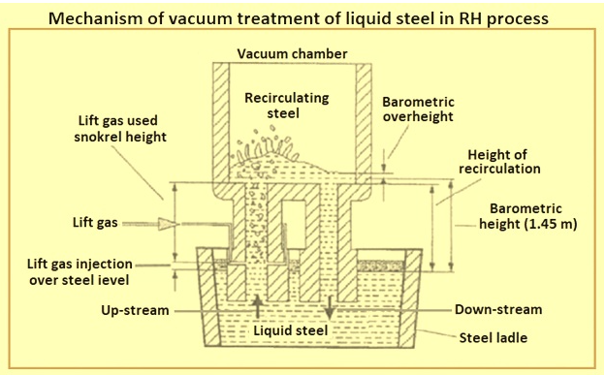
Fig. 3 Mechanism for vacuum treatment of steel in the RH process
Automotive and other exposed plates as well as plates for the electrical industry (e.g. transformers) are typical end products produced from liquid steel treated by RH/RH-TOP degassing equipment.
Operation steps
The various operational steps in the RH degassing process are described below. The reaction vessel is first preheated to the required temperature， which usually varies between 900 degrees Celsius and 1500 degrees Celsius， depending on the plant requirements.
The degassing process starts by moving the ladle with liquid steel to the treatment position using a ladle truck， and the reaction vessel is lowered or the ladle is raised to the desired level so that the breather is submerged in the steel. The degassing process is started after the two bifurcators are fully immersed in the steel. Before the breather is immersed， an inert gas， usually argon， begins to be injected in the gas line of the breather. Argon acts as a lifting gas to increase the velocity of the steel entering the inlet tube.
After the required immersion depth of the breather tube is reached， the reaction vessel is evacuated by means of a vacuum pump system， which is connected to the reaction vessel by a closed pipe (venting). A vacuum (negative pressure) is created and the liquid steel is drawn into the two breather vessels. The argon gas injected into the gas mixture increases the pressure in the upper limb breather. This pressure creates circulation of the liquid steel in the splitter. Metallurgical treatment steps such as degassing， oxygen blowing， adjustment of chemical analysis and temperature can now be performed. Depending on the superheat of the steel， alloy additions can be made at the end of degassing.
The steel in the reaction vessel is degassed and flows back to the ladle through the outlet nozzle. The degassed steel is slightly lower than the steel in the ladle. The buoyancy created by the density difference (the density of the colder degassed steel is greater than the density of the hot steel in the ladle) stirs the steel. The rate of circulation of the steel in the reaction vessel controls the degassing. The circulation rate depends on the amount of argon and vacuum in the elevator. The circulation time is usually between 20 and 30 minutes. Depending on its size， the RH degassing equipment has the capacity to circulate between 85 and 135 tons of steel per minute.
When the chemical composition of the molten steel is determined and found to be satisfactory， the vent tube of the degasser is removed from the molten steel， the argon is turned off， and nitrogen is introduced into the upper limb vent tube to prevent the injection tube from freezing. The degassing operation is then completed and the ladle is transferred to the post-treatment or receiver position.
During the production process， the operator is guided by a process automation system. The system uses a number of mathematical models to predict metallurgical parameters and establish set points， for example， calculating the steel temperature based on different receiving parameters and processing time cycles， and calculating the chemical composition by determining the received steel sample and the material added during processing. Predictions and set points are also created for the state of the degassing function， such as removing hydrogen and nitrogen based on initial content， degassing time， vacuum pressure profile， lift gas rate， and other factors， determining the state of decarburization by cycling through the carbon and oxygen content of the steel， and setting points for various functions such as oxygen blowing， vacuum， and lift gas modes.
In addition， the Level-2 system is connected to the production planning and process automation of the front and back cells as well as to the laboratory in order to provide all relevant data to the operator. Data tracking collects all relevant data from the Level-1 system and process models to create different heat and production reports. All this data is stored in a database， making the system ready for future data applications.
Availability of RH degassing equipment
In addition to shorter cycle times， the availability of the RH degassing equipment needs to be considered in order to facilitate the production schedule of the steel melting shop. Most critical is the time required to maintain the breathers. After processing a series of six heats， the nozzle requires intermediate maintenance (degassing， and refractory gunning). Depending on the specific slag and treatment conditions and the tools available， maintenance can take anywhere from 20 minutes to 60 minutes. More frequent maintenance work will result in a longer service life of the nozzle. After 60 to 300 heats， again depending on the treatment conditions as well as the quality of the refractory material and the design of the refractory plates， the refractory plates need to be replaced. Every 2 to 3 times， further maintenance of the refractory material is required， mainly in the bottom area. In today's RH degassing plants， vessels are exchanged for vent replacement and vessel maintenance in order to reduce plant downtime.

