Application of field oxygen generator in veterinary clinic

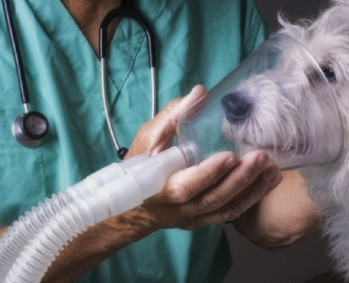
95% pure oxygen is used during and after any type of surgery. It helps keep animals stable until they can breathe effectively for themselves. In typical cases， the on-site oxygen generator is installed outside the veterinary clinic or hospital， and the air supply pipeline enters each operating room， so it will not occupy the minimum space of most operating rooms. On site oxygen generation can be effectively used in large and small veterinary clinics.

Why provide on-site oxygen for veterinarians
Like other medical institutions， veterinarians need to be able to rely on their oxygen supply. It is impossible to predict how much oxygen is needed. If the supply runs out， the pet's life will be in danger. Therefore， it is obvious why many veterinary clinics have switched from oxygen cylinders to on-site oxygen production.
By producing their own oxygen， vets never have to worry about running out.
It is much easier to simply set up the oxygen generator and forget about it than to monitor the oxygen tank level and schedule pick-up and delivery.
Over time， on-site oxygen generation is also more cost-effective， because it only needs to pay the upfront cost， and the maintenance cost is the lowest over time. In addition to the lowest daily maintenance cost， there is no need to deal with recurring expenses.
On site oxygen selection for veterinarians
In the field gas system， we provide all types of oxygen generators for any application. This includes:
Custom oxygen generator designed for the specific needs of veterinarians.
The filling station can be used at 93%， 95% or 99% purity， allowing veterinarians to fill their own cylinders as needed， and the cost is only a small part of it.

