Nitrogen - an essential gas for the oil and gas industry
Nitrogen， a colorless， odorless gas， is a non-hydrocarbon inert gas used for a variety of functions during the drilling， operation and completion phases of oil and gas wells， where safety is a top priority for the oil and gas industry. Nitrogen ensures safety in tank cleaning operations and other situations where inert gas is required.
Since nitrogen is immiscible (or unmixed) with oil and water， nitrogen injection procedures or nitrogen flooding using XITE's on-site nitrogen generators can be used to purify hydrocarbons from injection wells to production wells.

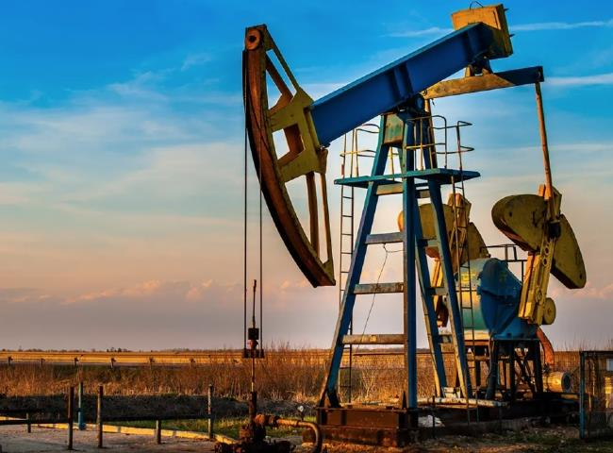
Let's understand the importance of nitrogen in the oil and gas industry?
Nitrogen is used in a wide range of applications in the oil and gas industry， mainly for filling， cleaning and covering of pipelines and tanks， but also as an inert gas for hydrocarbon vessels and pipelines. In other words， it is used to limit the oxygen content so that it cannot react with hydrocarbons and form explosive mixtures.
Nitrogen venting.
Nitrogen is used in a process known as pipe-filling. For example， pressurized nitrogen is used as a driving force to propel pigs through a pipe. It can also be used to clean the pipeline after filling is complete. In this case， the dry gas is passed through the pipe without the pigs to dry any remaining moisture in the pipe.

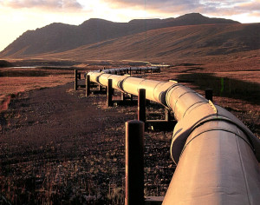
Nitrogen purging.
Nitrogen purging is the inerting of the atmosphere of hydrocarbon vessels and tubing. In other words， it is limiting the amount of oxygen so that it cannot react with hydrocarbons to form some explosive mixture.
In oil and gas industry terminology， the purification process is carried out in a variety of applications. Generally， in order to activate gas wells， clean pipelines， pigging or transfer pressure， and also to reduce the oxygen content in the pipeline， nitrogen is circulated at a high pressure of 80-100Kg/cm2 from one end called the annulus (casing) and the gas is returned at the other end.
Nitrogen purging reduces the chances of explosive/explosive mixture.
Nitrogen Filling.
Nitrogen filling (also known as tank filling or tank lining) is a process in which nitrogen is applied to an empty storage facility to improve safety and provide a buffer for incoming hydrocarbons. Nitrogen filling is safe and reliable and maintains a continuous protective layer of gas on top of the working substance. The moist air in the headspace is replaced with high purity， inert and completely dry nitrogen. A precise valve control system ensures that as the tank is filled or emptied， the nitrogen level is automatically adjusted to maintain the protective layer.
In summary， nitrogen plays an important role in the oil exploration industry and reduces the potential for explosive/explosive mixtures.

