Baidu Encyclopedia of Air Separation

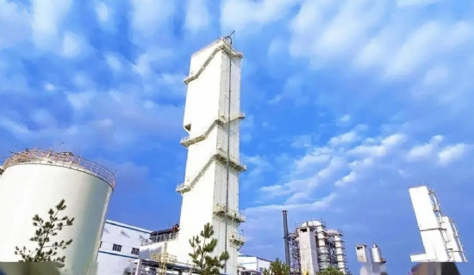
Air Separation
Simply put， it is a set of industrial equipment used to separate the various components of gases in air to produce oxygen and nitrogen.
The specific process is
Compressed air from the compressor， the molecular sieve to remove water， carbon dioxide， hydrocarbons and other impurities， part of the air is sent directly to the upper tower of the distillation tower， the other part of the expansion machine into the expansion of refrigeration， was sent to the lower tower. Distillation tower， rising steam and falling liquid after heat exchange， in the top of the upper tower can get a high purity of nitrogen， in the bottom of the upper tower can get a high purity of oxygen.

