Benefits of using nitrogen purge

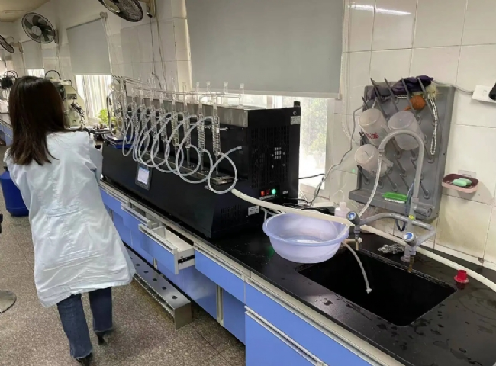
Processed foods are something that we all consume almost every day. They're easy to carry and store， and they're convenient. But did you know that packaged foods require a lot of prevention to get from where they are processed to the store and finally to your kitchen? Processed foods are typically packaged in boxes or bags. In order to keep these foods safe for a longer period of time， it is necessary to remove oxygen from the container because if the food comes in contact with oxygen， it will spoil. Due to oxidation， the product will be wasted. However， if the packaging is purged with nitrogen， the food product can be preserved. In this article， we will discuss how nitrogen used for flushing can be useful.
What is nitrogen?
Nitrogen (a chemical element with the symbol "N") offers many different uses for a variety of manufacturers. There are many industries that require nitrogen in their manufacturing processes. The pharmaceutical industry， food packaging companies， and brewing companies， all rely on nitrogen to complete their industrial processes.
Nitrogen for flushing
Have you ever shaken a bag of potato chips? If so， you must have felt the chips banging around in the package and felt like there was a lot of air in its bag. But this is not the air we inhale. Those gases in the bag of chips are nitrogen gas that does not contain oxygen.
All snack bags are filled with nitrogen， not to make them look bigger， but to protect the food inside the bag from oxygen exposure and physical damage. When nitrogen is flushed away， it replaces oxygen and cushions the contents.
Nitrogen doesn't react with food the way oxygen does， so food stays fresh longer. Nitrogen does not affect the taste or texture of processed foods， allowing them to be perfectly preserved. This gas is perfectly safe. In fact， you are often exposed to nitrogen because it makes up about 70% of the air you breathe.

