Nitrogen generators for the refrigerant and air conditioning industry

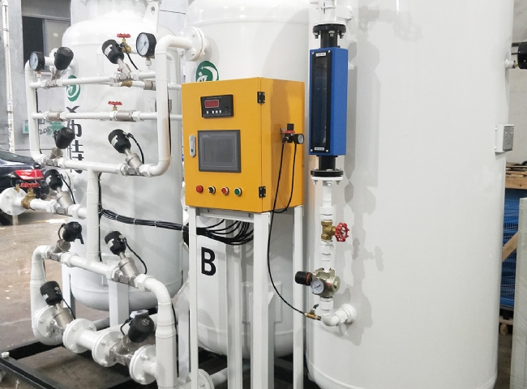
PSA Nitrogen Generators， Nitrogen Equipment， Nitrogen
XITEc is a designer， manufacturer and supplier of PSA nitrogen generators. Nitrogen is used in different fields such as HVAC， metallurgical industry， chemical industry， food packaging industry， pharmaceutical industry， electronics industry and sulphur grinding industry. HVAC includes heating， ventilation and air conditioning. HVAC is the effective system that exists around each of our air conditioners， whether they are in residential areas or in industrial premises. The focus of HVAC systems is to provide thermal control and comfort in a room using heat transfer， fluid dynamics and thermodynamics.
HVAC requires nitrogen throughout the testing， manufacturing and ongoing maintenance process. Nitrogen is used for pressure testing and cleaning of copper coils. Many times， manufacturers of HVAC systems pressurize the coils prior to shipment to verify that there are no leaks in them.
Nitrogen also eliminates oxidation of metals because it impedes the presence of moisture during the leak testing process.
In addition to these uses， nitrogen is used in gas-assisted laser cutting of sheet metal cabinets.
Since nitrogen makes up 78% of the atmosphere， the most advantageous option for all nitrogen users is to produce an interrupted supply of nitrogen for your industrial use at your own premises. Our systems are easy to install and use， and are manufactured with the latest technology. With our on-site gas generators， you can eliminate the worry of delivering or running out of gas.

