1200 cubic meters of XITE membrane nitrogen equipment for coal mine fire protection application

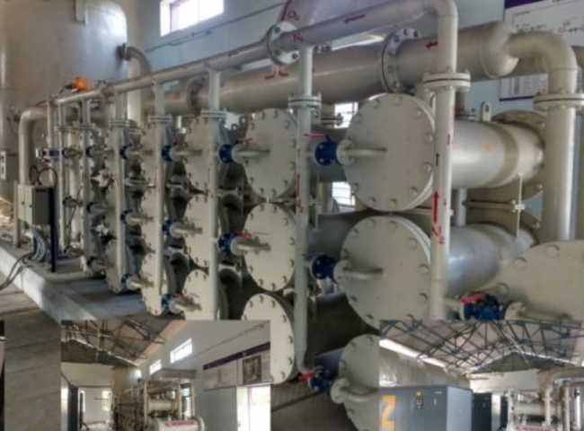
The 1200 cu. ft. nitrogen generator is a very large nitrogen plant， 98% pure， 1200 cu. ft. of nitrogen is delivered uninterruptedly by the XITE nitrogen generator for all points of the mine. #The XITE team worked closely with the customer to deliver the equipment on a turnkey basis， guiding the customer through the entire process of installation and commissioning of the equipment from the very beginning. Complete supply. We supplied air compressors， instrumentation， switchboards， membrane nitrogen equipment， and SCADA automation equipment. We also provided a design solution for the shed where the equipment would be located.

