Food Grade Nitrogen Supply - Specifications & Applications

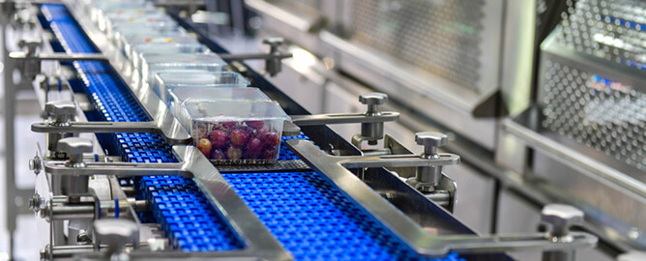
Gaseous nitrogen has unique physical and chemical properties that allow it to play a key role in the food and beverage manufacturing industry. Nitrogen is inherently inert and can be used to remove oxygen and moisture from food processing， thereby preventing easy spoilage/oxidation damage and extending shelf life.
Having established the importance of nitrogen in the food manufacturing process， manufacturers must adhere to strict standards for compressed air systems in order to supply high quality food grade nitrogen to their associated processes.
This article will discuss the Food and Drug Administration (FDA) and International Standards Organisation (ISO) standards for food-grade nitrogen and the various ways in which this compound can be used safely in food processing.
What is food grade nitrogen?
Food grade nitrogen is a simple mixture of oxygen poor/nitrogen rich air used in food preparation to maintain freshness and extend shelf life. While nitrogen for food packaging and processing can be supplied to food manufacturers in cylinders， the most economical way to obtain the gas is by using a mobile nitrogen unit on site.
Standards for food-grade nitrogen
The ideal nitrogen concentration for use in food preservation activities is 99.0% or higher. The associated oxygen concentration should be less than 1%， while the concentrations of carbon monoxide and carbon dioxide in the air mixture should be less than 10 ppm and 300 ppm respectively. in addition， the moisture concentration should be less than 55.8 ppm and the gas mixture should be odourless.
FDA standards for the use of nitrogen in food
The FDA gives strict guidelines for the use of food-grade nitrogen， including its physical and chemical description， as well as the purity of the nitrogen and the method of application. The FDA affirms the safe nature of food grade nitrogen， provided the following conditions are met
Nitrogen is used as a propellant， aerator and gas
the concentration of nitrogen used for food preservation does not exceed the most recent Good Manufacturing Practice
ISO standards for food grade nitrogen
ISO/TS 220022-1:2009 outlines a standard for food grade nitrogen which emphasises the requirements for the construction and use of nitrogen synthesis equipment for food preservation. aspects covered by the ISO guidelines are: nitrogen generation， processing， filling， purging and modified atmosphere packaging (MAP).

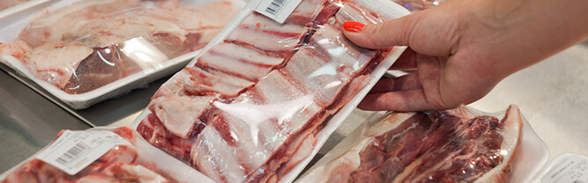
Applications of food grade nitrogen
The main applications of food grade nitrogen are as follows.
Modified atmosphere packaging
Nitrogen-filled beverages (nitrogen-filled coffee and beer)
modified atmosphere packaging
Modified Atmosphere Packaging refers to special packaging techniques that allow food products to retain their freshness over a longer period of time.MAP uses either passive or active methods to control the internal environment in which food is preserved.
Passive MAP techniques use special packaging materials/films to isolate the stored food from external oxidising conditions that cause rapid spoilage. The sealing film regulates the temperature， humidity and gas diffusion rate around the packaged food to keep it fresher for longer.
Active MAP involves the circulation of a carefully composed gas mixture through the packaged food. Typically， the main component is nitrogen with a small amount of oxygen. This air mixture slows down the oxidation process and thus extends the shelf life.
Nitrogen-infused beverages
The use of nitrogen in the preparation of beverages has gained most popularity due to its effect on flavour and texture. Nitrogen can be integrated into the brewing process of coffee， beer and other beverages.
Nitrogen-infused coffee
Ready-brewed coffee infused with pure nitrogen offers a unique and novel perspective on the favourite beverage of millions of people around the world. The application of pressurised nitrogen to cold brew coffee powder changes the flavour and texture of the final coffee. When delivered through a pressurised nozzle， a frothy layer forms at the top of the coffee cup， similar in appearance to beer， which some connoisseurs claim tastes even better.
Nitrogen-infused beer
Just like coffee， brewers began experimenting with nitrogen. Instead of carbonation with carbon dioxide， nitrogen is used to achieve a frothier beer with a smoother taste and consistency.
Benefits of food grade nitrogen generators
The larger the scale of a food production process， the higher its need for food-grade nitrogen. While smaller operations can use food grade nitrogen in tanks and cylinders for transport and storage， this method is not very effective in larger food processing facilities.
For medium to large scale food processing operations， the use of an on-site nitrogen generator is highly recommended to synthesise the required quantity of gas. Key benefits of using a food grade nitrogen generator include
Lower overall running costs compared to nitrogen cylinder procurement
Rapid onsite generation of the required quantity of gaseous nitrogen with minimal waste
Eliminates the hazards associated with nitrogen cylinder storage while saving vital floor space
Efficient production of high quality gas

