Industrial oxygen generators in metal and metallurgical cutting applications

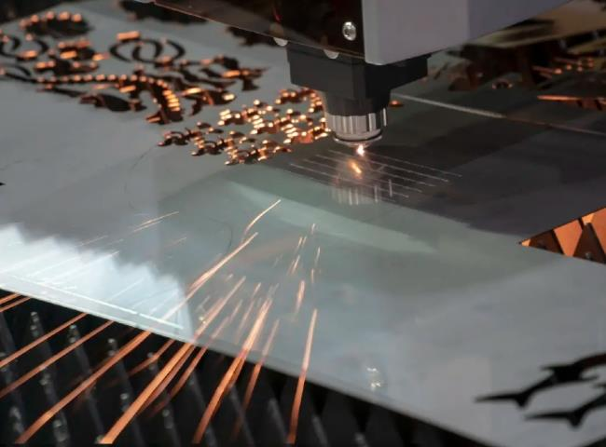

The concept of laser cutting
The CO2 laser beam is directed at the material surface through the nozzle， the material absorbs energy in to a molten state， and， the auxiliary gas blows the liquid material away. The melting area moves gradually with the cutting direction table to produce a continuous cut， which is laser cutting. The application of oxygen cutting began on the laser compound machine APELIO 357 Ⅱ. 2001 the introduction of the laser cutting machine BTL3000 also brought a new processing process nitrogen cutting. The use of nitrogen cutting method not only improves the quality of cutting， but also expands the processing range.
The characteristics of the oxygen machine for cutting
The main advantage of oxygen machine cutting is high cutting quality and wide processing range， but there is also the disadvantage of high cost. We can elaborate on these features by comparing them with oxygen cutting as follows.
1.Equipment Introduction
Oxygen generator consists of air compressor system， air purification system， nitrogen generator (PSA nitrogen machine， nitrogen equipment)， carbon carrier purification device and booster equipment. The system outlet nitrogen flow rate is 10Nm3/h～500Nm3/h， nitrogen purity is 99.9995%， nitrogen pressure can be increased to 1.4-2.8Mpa by booster.
2.Processing range
Oxygen-assisted combustion increases the heat and improves the cutting thickness. The advantage is low cost， mainly applied to carbon steel. Nitrogen does not assist combustion， the melting area temperature is lower， suitable for processing aluminum， brass and other low melting point materials. Nitrogen protects the cut from oxidation and can also be used for oxidation-free cutting of stainless steel.
3. Cutting cost
The price of high-purity nitrogen is three times higher than high-purity oxygen. Oxygen cutting air pressure requirements (1 ~ 4) * 105Pa， nitrogen requires (10 ~ 140 * 105Pa. For example， cutting 2CM thick stainless steel plate， oxygen requires pressure 4 * 105Pa， gas consumption 2.3m3 / h， nitrogen corresponds to 14 * 105Pa， 15.2m3 / h. And nitrogen cutting requires high power， corresponding to an increase in energy consumption. The comprehensive cost of nitrogen cutting is more than 15 times that of oxygen cutting.
4. Cutting quality
According to the use of auxiliary gases， laser cutting can be divided into two cutting methods: oxygen and nitrogen. In oxygen cutting oxygen is involved in combustion and the melting position temperature is close to the boiling point. High temperature leads to a violent reaction， can not guarantee a smooth section; in addition， coupled with the oxidation reaction， increased heat-affected zone， so that the cutting quality is relatively poor， prone to slit width， section beveling， poor surface roughness and welding slag and other quality defects. Nitrogen cutting in the material completely rely on laser energy melting， nitrogen blowing out of the cut and avoid inappropriate chemical reactions. Melting point area temperature is relatively low， coupled with the cooling and protection effect of nitrogen， the reaction is smooth and uniform， and the cutting quality is high. The section is delicate and smooth， with low surface roughness and no oxidation layer.

