Working principle and comparison of PSA and membrane nitrogen generators

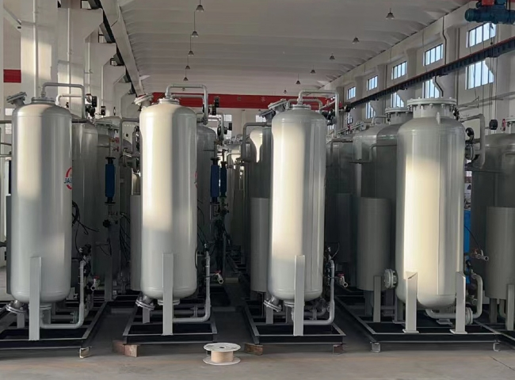
Hitt is a manufacturer of nitrogen generators based on membrane separation and variable pressure adsorption (PSA) technologies. However， before purchasing a generator for your industrial use， it is necessary to understand both technologies before deciding which one is best for your application.
How PSA nitrogen generators work
Using compressed air， variable pressure adsorption (PSA) generators produce an interrupted supply of nitrogen. These generators use pretreated compressed air that is filtered through a carbon molecular sieve (CMS). Oxygen and trace gases are absorbed through the CMS， allowing the nitrogen to pass through. This filtration is performed in two towers， both of which contain a CMS.
When the in-line tower discharges contaminants， it is referred to as a regeneration mode. In this process， oxygen with smaller molecules is separated from the nitrogen and the liner in the screen adsorbs these smaller oxygen molecules. Due to the large size of the nitrogen molecules， they cannot pass through the CMS and the result is the desired pure nitrogen.
Working principle of the membrane nitrogen generator.
In a membrane nitrogen generator， air is filtered and passed through various membranes of advanced technology. These membranes have hollow fibers that work like reverse fibers and by permeation， nitrogen is separated.
The purity of the nitrogen varies with the number of membranes in the system. Different levels of nitrogen purity can be obtained by using different membrane sizes and increasing or decreasing the pressure. The level of nitrogen purity is slightly lower than that obtained with a PSA generator.
Point-by-point comparison of PSA and membrane nitrogen generators

Topic | Pressure Swing Adsorption | Membrane Technology
Purity Level | - PSA Nitrogen generators have higher purity levels.  - MVS PSA N2 generator user can achieve a set purity level between 95% and 99.9995%. | - Users of membrane technology generators can achieve the purity level between 95% and 99.9% only.
Reliability | - PSA N2 generators are slightly complicated to maintain when compared with Membrane Generators.  - There are only a few moving parts in a PSA N2 generator. And， if proper maintenance is done， these types of generators can last for several years. | - Membrane generators are easy to maintain and operate.  - There are no to only a few moving parts in a membrane generator and if it is properly maintained， it can work perfectly for many years.
Maintenance | - PSA generators require zero to a little maintenance.  - The only maintenance required in PSA generator is simply changing filter cartridge.  - Molecular sieves， where most of the gas filtering process takes place， can last for more than 10 years. | - Membrane generators require very little maintenance.  - Simply with dry & clean feed air， the only maintenance required is changing filter cartridges.
Consistency | - PSA generators can deliver the same high volume of pure Nitrogen throughout the life of the generator. | - The capacity reduces significantly as the demand for pure gas increases.

