Chemical industry - Industrial gas demand in the chemical industry

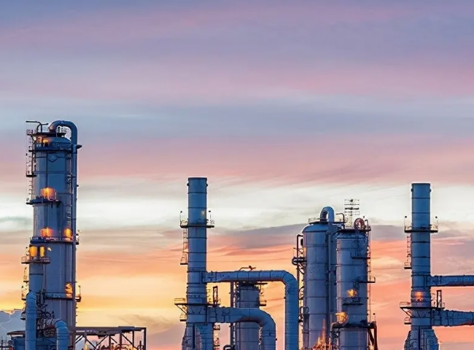
All three gases produced using XITE's on-site gas generators - nitrogen， oxygen and hydrogen - can find use in chemical industry production.
Nitrogen
The use of nitrogen is by far the most common in the chemical industry.
Customers need nitrogen in all stages of handling， manufacturing， and packaging chemicals for a variety of uses.
Nitrogen is widely used as a gas to replace oxygen and other undesirable gases. Nitrogen itself is highly selective in its reactions and it is largely inert， which allows nitrogen to be used in a wide range of applications. Nitrogen is also abundant， with 78% of it present in the atmosphere.
Hitt's nitrogen generators are based on two technologies - membrane and PSA. membrane nitrogen generators are very suitable and cost effective where high flow rates and lower purity nitrogen can be accepted. Where high purity nitrogen is required， for example to maintain oxygen levels at the ppm level， PSA nitrogen generators are used.
In chemical industry production， some of the major processes that require nitrogen are - purging (before and during batch processing)， filling (tanks and other storage volumes)， packaging (to prevent reactions with oxygen and other volatile chemicals).
Oxygen
Many chemicals are processed compounds and oxygen is necessary where oxy compounds are produced. XITE offers industrial grade PSA and VPSA oxygen generators， depending on the amount of oxygen required. 95% oxygen purity (most of the rest is argon and trace nitrogen) can be provided by PSA nitrogen generators， and 93% oxygen purity can be easily achieved by large volume VPSA oxygen generators.
Hydrogenation
Hydrogenation is a common process for preparing many chemicals， and many chemical processing companies have a large demand for hydrogen. Although hydrogen is found in abundance in nature (H2 in H2O)， it is not readily available in its molecular form. Therefore， in order to obtain hydrogen， it must be "extracted" from a source that is rich in hydrogen. Some of the most common hydrogen feedstocks are (1) water， (2) natural gas (methane)， (3) methanol， (4) ammonia and other hydrocarbons such as naphtha， synthesis gas from oil refineries， etc.
Hydrogen is also widely used in laboratories in the chemical industry where it is used as a carrier gas or as a FID for gas chromatography. for this application， very compact and small laboratory hydrogen generators， about the size of a typical computer CPU， can be used and provide a continuous， pure and reliable supply of hydrogen gas.
Hydrogen is primarily obtained by the customer in cylinder cascades or in tubular trailers. However， on-site production is considered a safer and more reliable way to produce hydrogen because it avoids the constant need to handle cylinders or pipelines.
XITE offers different technologies for on-site hydrogen production， including water electrolysis (bipolar high pressure) and water electrolysis using the latest PEM technology from Proton (NEL Hydrogen). We also offer systems that use hydrocarbon conversion， such as natural gas reformers， commonly known as steam methane reformers (SMR) and methanol crackers. In addition， we are one of the world's specialized manufacturers of ammonia crackers， which provide a good mixture of nitrogen (25%) and hydrogen (75%) with very low trace ammonia content in the product gas.
- In short， no matter which gas is needed in chemical processing， XITE is a one-stop shop for providing customers with a wide range of gas generators. We have been doing this for a long time and are known for providing high quality， well designed， reliable and long lasting gas generators that have stood the test of time.

