Nitrogen generators for oil depot applications

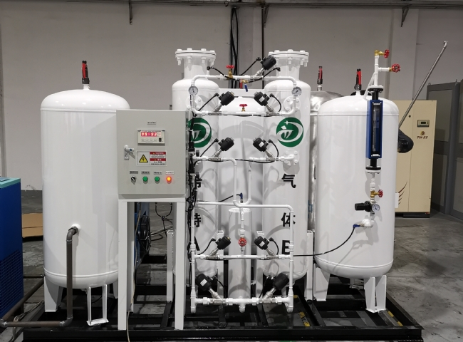
PSA Nitrogen Producer， Nitrogen Producer， Nitrogen
Suzhou XITE is a leading designer， manufacturer and supplier of PSA nitrogen generators. Nitrogen is widely used and the facility has most of the oil transportation pipeline network， directly from the ship to the storage tank. The storage tanks and pipelines are kept under nitrogen and the pipelines are cleaned after each transfer.
The use of nitrogen is ideal for petroleum applications such as oil and gas platforms， enhanced oil recovery， refineries， oil and gas extraction and fracking. It is effective in slowing down or preventing corrosion， product deterioration and contamination of spray pipes and， most importantly， eliminating the risk of explosions and fires. In oil industry production， nitrogen is typically used in large volumes and at high pressures， with a purity of no less than 95%， for pipeline filling to keep pipelines open and for well injection to push product to the wellhead for extraction. Low-pressure applications include pipeline purging to maintain an inert atmosphere during maintenance， purging of control devices， inerting of flare gases， and most commonly， covering of gases or storage tanks. For assistance in sizing a nitrogen generator to meet your needs， please contact us and visit our website at http://xitegas.com/.

