Bionics - A new aquaculture paradigm has begun

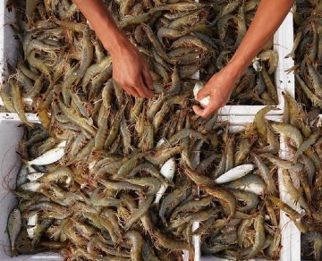
Aquaculture is the most advanced technology in shrimp farming， providing natural live food "copepods" for the larvae before stocking， pond water stability， improving good survival rates， fastest growth rates， high profitability， fully sustainable and not destructive to our nature.
In the last decade， shrimp farming has been one of the major aquaculture industries， especially in Asia and South America， and in the future it is expected to become one of the leading shrimp farming industries in the world， with a very large domestic and foreign market demand. Environmental problems in shrimp farming have arisen at all farming sites due to the following factors
Intensive shrimp farming management with very high population densities in the ponds， 200，000 to 1，000，000 post-shrimp larvae per hectare of pond， generates several tons of organic waste in the shrimp pond environment， and many of the organic waste materials in their bodies are in the form of organic waste compounds that cannot be utilized by phytoplankton through photosynthesis. Such organic waste compounds in shrimp farming are quite stable and have no tendency to break down into simpler， usable forms. The oxidation of these organic waste compounds consumes dissolved oxygen deep in the shrimp pond culture substrate and forms toxic metabolites such as hydrogen sulfide， methane， ammonia， and nitrite， thus greatly increasing shrimp farming mortality.
The supply of surplus feed and dead phytoplankton cells causes the accumulation of undesirable organic wastes and toxic gases dissolved in the bottom of the shrimp pond aquaculture shrimp pond bottom is polluted and deteriorated.
When this happens， the soil on the bottom of the shrimp pond， in most cases when the bottom of the aquaculture shrimp pond is contaminated and deteriorated， mortality occurs. When this happens， the shrimp pond soil becomes acidic， harbors bacteria， damages gills (black or brown gills)， burns and breaks tails， affects metabolism， blue shrimp syndrome (due to nutrient deficiencies) occurs， the molting process is disrupted， and fouling， vibriosis and other viral diseases occur， leading to mortality.

