Overview of valves

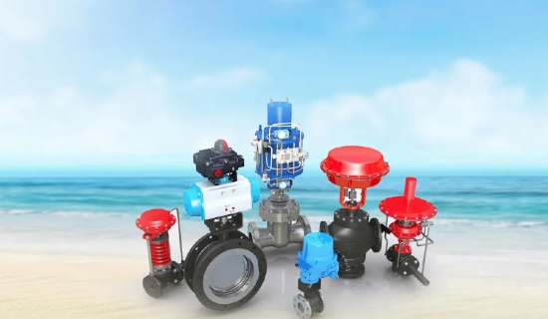
Valve is the control equipment of fluid pipeline， its basic function is to connect or cut off the flow of pipeline medium， change the flow of medium， change the direction of medium transmission， adjust the pressure and flow of medium， and protect the normal operation of pipeline equipment.
A large number of industrial valves are used after the invention of steam engine in Watt， nearly two or three decades， due to the needs of petroleum， chemical， power station， metallurgy， shipping， nuclear energy， aerospace and other aspects of the valve to put forward higher requirements， prompting people to research and production of high parameters of the valve， its working temperature from ultra-low temperature -269 ℃ to high temperature 1200 ℃， or even up to 3430 ℃， working pressure from ultra-vacuum 1.33x10-8Mpa (1x10-1㎜ Hg) to ultra-high pressure 1460MPa， valve diameter from 1mm to 600mm， even up to 9750mm， valve materials from cast iron， carbon steel to titanium and titanium alloy， high-strength corrosion-resistant steel， etc.， valve drive from manual development to electric， pneumatic， hydraulic， program control， CNC， remote control， etc..
With the continuous development of modern industry， valve demand is growing， a modern petrochemical equipment requires tens of thousands of various types of valves， valves used in large quantities. Open and close frequently， but often due to manufacturing， the use of selection， improper maintenance， run， bubble， drip， leak phenomenon， which causes flames， explosions， poisoning， scalding accidents， or resulting in poor product quality， energy consumption， equipment corrosion， increased material consumption， environmental pollution， and even cause production downtime and other accidents， has become common， so people want to obtain high-quality valves， but also require the use of improved valve， maintenance Level， when engaged in valve operators， maintenance personnel and engineering and technical personnel， put forward new requirements， in addition to careful design， reasonable selection， correct operation of the valve， but also timely maintenance， repair valves， so that the valve "run， bubble， drip， leak" and all kinds of accidents to a minimum.

